` 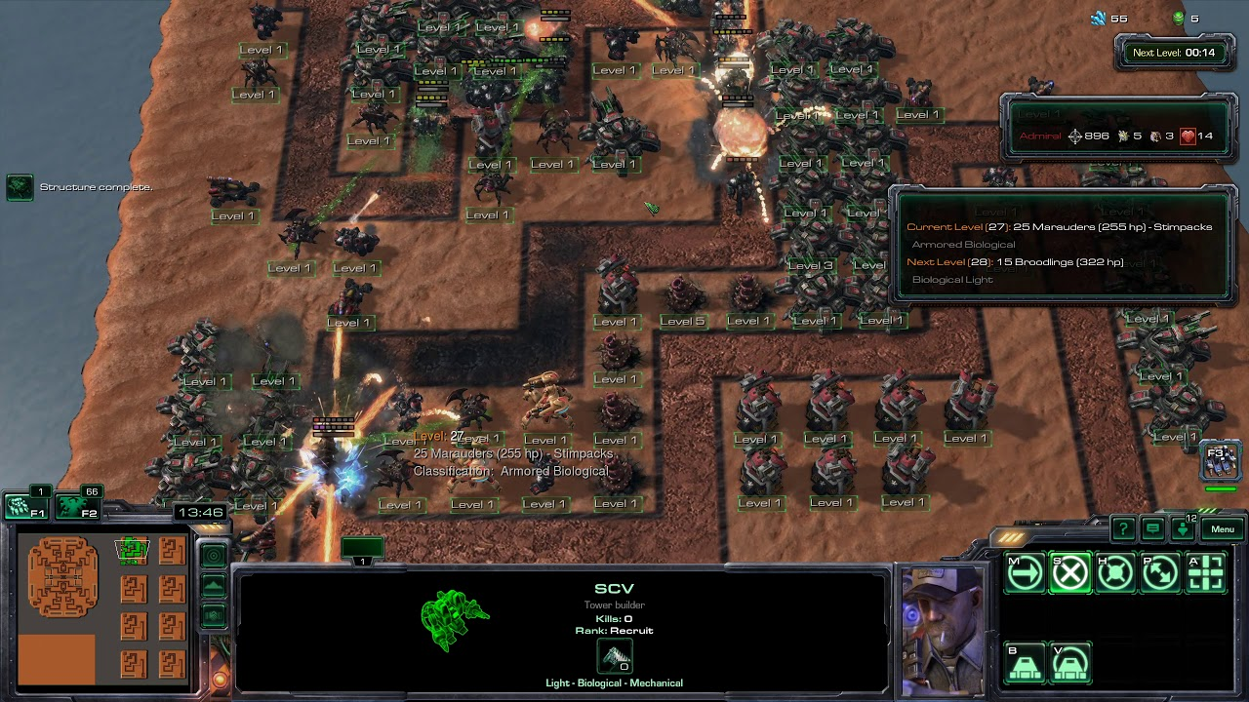

Fallout 4: Threshold Experiment

Version 1.0

|  |  |
| --- | --- |
| Designer: | Donghua Li |
| Document Date: | 8/5/2023 |
| Intended Level Delivery Date: | 7/19/2023 |

**Document Revisions Table**

|  |  |  |  |
| --- | --- | --- | --- |
| **Version** | **Description** | **Requestor** | **Date** |
| 1.0 | Initial Document | Professor. Stephens | 5/30/2023 |
|  |  |  |  |
|  |  |  |  |
|  |  |  |  |
|  |  |  |  |

## Table of Contents

Table of Contents 2

Table of Figures and Tables 2

Level Summary 4

Quick Summary 4

Level Feature Overview 4

Development Schedule 5

Level Logic Flow Chart 6

Level Overview 7

Overview Map 7

Narrative Flow Chart 8

Turret Stats Charts 8

Waves Design Charts 9

Level Details 12

Detail Maps 12

General Flow 12

Aesthetic References 14

Experiment Field Decoration 14

References 15

Appendices 16

Appendix A: New Skills / Gameplay Mechanics 16

<Mechanic A> Turret Activate Sniper 16

<Mechanic B> Turret Upgrade Sniper 16

<Mechanic C> Turret Type Changing Wrench 16

Appendix B: Character Descriptions 17

NPC 1: Raynor 17

NPC 2: Terra 17

Appendix C: Key Asset Needs 18

## 

## Table of Figures and Tables

Figure 1 Level Logic Flow Chart [1] 6

Figure 2: Overview Map [3] 7

Figure 3 Image of Narrative flow [1] 8

Table 1 Table of Turret Stats 8

Table 2 Table of Turret Skills 8

Table 3 Matrix of Enemies Abbreviated Name and HP 9

Table 4 Matrix of Weapons' Actual DPS against all enemies 9

Table 5 Matrix of Turrets' Upgrade Fees 9

Table 6 Matrix of Wave in Level 9

Table 7 Matrix of Wave Spawning Sequence 10

Figure 4: Walkthrough of Interior Experiment Field[3] 12

Figure 5 Contact Sheet for Experiment Field Interior Decoration [2] 14

# Level Summary

## Quick Summary

Threshold Experiment is a Fallout 4 level with classic tower defense gameplay. In this level, the player is introduced to use special snipers with special ammos to control different types of turrets to defend against the various invading enemies.

## Level Feature Overview

|  |  |  |
| --- | --- | --- |
| Category | Sub-Category | Feature List |
| Player | Player Weapons | * Turret Activate Sniper * Turret Upgrade Sniper * Turret Type Changing Wrench * Cryo Grenade * Cryo Mine * Pulse Grenade * Pulse Mine * Molotov Cocktail |
|  | Player Skills/Abilities | * Use Turret Activate Sniper to activate or reset the sniper * Use Turret Upgrade Sniper to Upgrade Sniper * Use Turret Type Changing Sniper to change the type of a turret so that it can fire different ammo * Manage which path to open and which path to close * Use grenades and weapons to assist the defense |
| AI | Enemies | * Ghoul (Wave 1) * Hound (Wave 2) * Ghoul + Hound (Wave 3) * Synths (Wave 4) * Ghoul + Synths (Wave 5) * Death Claw (Wave 6) * Death Claw + hound (Wave 7) * Ghoul +Hound + Synths (Wave 8) * Death Claw + Synths (Wave 9) * Death Claw + Hound + Synths (Wave 10) |
|  | Friendlies | * Machinegun Turret MK III, MK V, MK VII * Laser Turret , Heavy Laser Turret, Terminal Laser Turret (Custom Stats) * Frozen Turret I, Frozen Turret II, Frozen Turret III, (Custom Stats) * Raynor * Terra |

|  |  |  |
| --- | --- | --- |
| Category | Sub-Category | Feature List |
| Challenges | Gameplay Themes | * Tower Defense * Resources Management (Using Caps to buy different ammos for custom weapons) |
|  | Obstacles/Hazards | * N/A |
|  | New/Unique Gameplay | * Refer to Appendix A |
| Context | Where Fits in Game | * A standalone Side Quest |
|  | Challenge Fit | * The level can be played and completed by player in any level * Challenges of setting up different type of turrets to handle different enemies regarding to their weakness * Challenges of managing resources(caps) retrieved from killed enemies in each wave |
|  | Additional Info | * N/A |
| Aesthetics | Major Visual Themes | * Fallout 4 Industrial + Institute-style |
|  | Setting/Mood | * N/A |

## Development Schedule

|  |  |
| --- | --- |
| Milestone | Date |
| LDD | 5/30/2023 |
| Whitebox | 6/5/2023 |
| Initial Gameplay | 6/19/2023 |
| Gameplay Complete | 7/3/2023 |
| Aesthetics | 7/10/2023 |
| Launch | 7/19/2056 |

## Level Logic Flow Chart

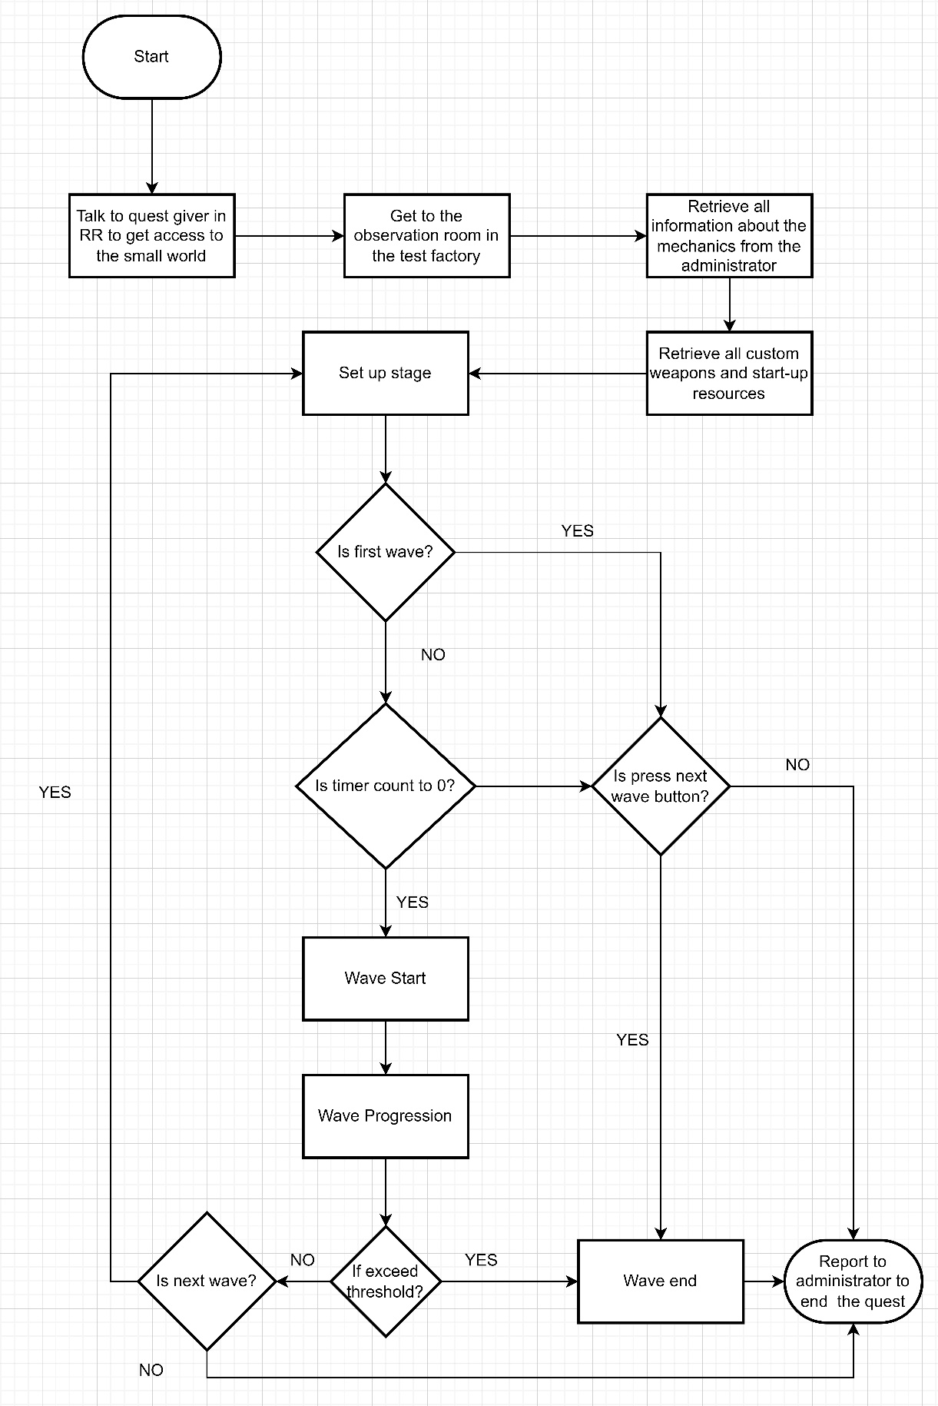

Figure Level Logic Flow Chart [1]

## Level Overview

### Overview Map

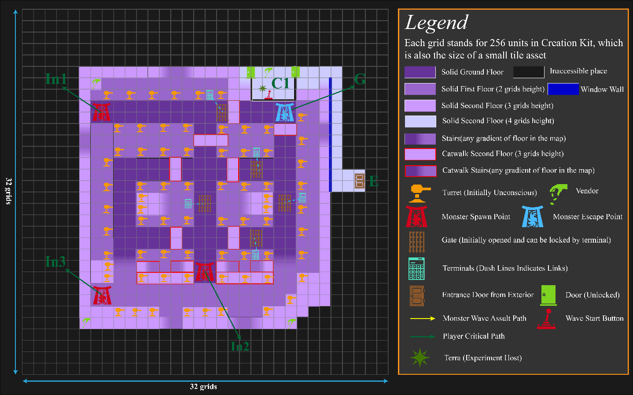



Figure : Overview Map [3]

|  |  |
| --- | --- |
| Map Label | Gameplay Summary |
| E | The entrance as well as the exit to the exterior world |
| C1 | Control room. The player will meet with Terra (Experiment Host) for the information about the threshold experiment, all custom weapons and other details about the experiment. |
| In1 | Spawn point 1 of wave enemies |
| In2 | Spawn point 2 of wave enemies. Only Synth enemies will spawn from this spot |
| In3 | Spawn point 3 of wave enemies |
| G | The escape point of the wave enemies. Whenever a monster reaches here, it will be disabled, and the player will can a notice about it |
| A,B,C,D,E | Gate can be opened or close by the player.   * Each time of opening will cost 100 caps * Gate A, B, E will be prevented to be all closed at the same time via script |

## Narrative Flow Chart

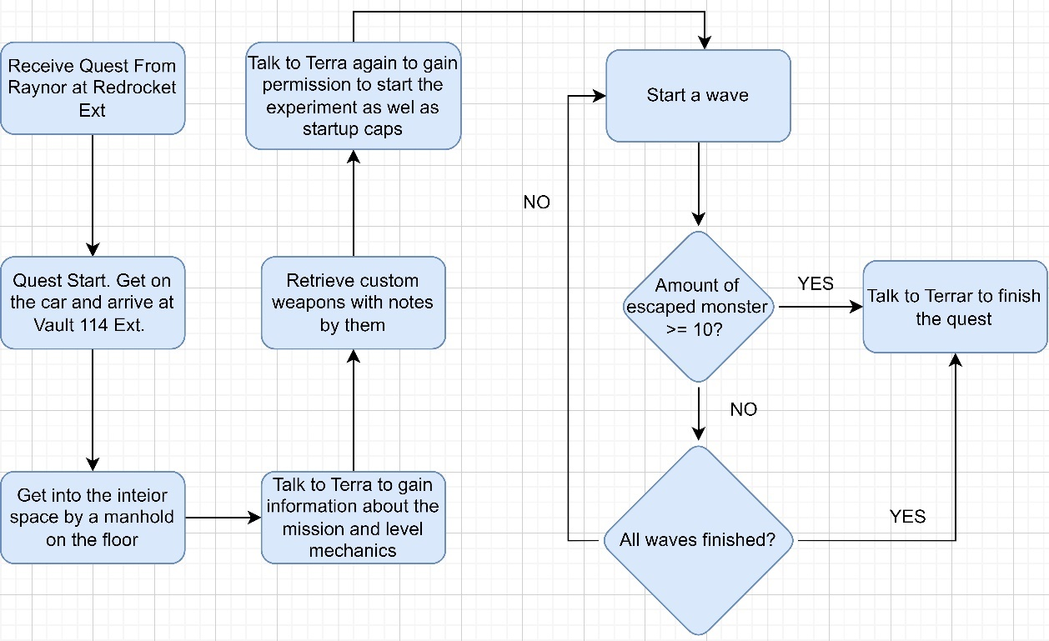

Figure Image of Narrative flow [1]

## Turret Stats Charts

Table Table of Turret Stats

|  |  |  |  |  |  |  |  |  |  |
| --- | --- | --- | --- | --- | --- | --- | --- | --- | --- |
| Actor Name | MK III | MK V | MK VII | Laser turret I | Laser turret II | Laser turret III | Frozen Turret I | Frozen Turret II | Frozen Turret III |
| Lvl | 16 | 28 | 40 | 16 | 28 | 40 | 16 | 28 | 40 |
| Attack | 15 | 45 | 50 | 18 | 30 | 30 | 5 | 5 | 10 |
| Range | 2048 | 2048 | 2048 | 1024 | 1024 | 1024 | 2048 | 2048 | 2048 |
| DPS | 112 | 337 | 374 | 134 | 675 | 675 | 2 | 2 | 374 |

**Note:** DPSs list here do not include the extra DPS from turret skills

Table Table of Turret Skills

|  |  |  |
| --- | --- | --- |
| Actor Name | Skills | Ult DPS |
| MK III | N/A | 112 |
| MK V | Ingite, 5 dps for 3 seconds | 342 |
| MK VII | Explosive, 25 for each hit | 561 |
| Laser turret I | N/A | 134 |
| Laser turret II | N/A | 675 |
| Laser turret III | Explosive reducing 50% Energy Resistant around 256 units | 675 |
| Frozen Turret I | Slowing down target for 50% | 2 |
| Frozen Turret II | Slowing down target for 50% | 2 |
| Frozen Turret III | Explosive, slowing down enemies 256 units around for 50% | 94 |

## Waves Design Charts

Table Matrix of Enemies Abbreviated Name and HP

|  |  |  |  |  |
| --- | --- | --- | --- | --- |
| Name | Type | Abbreviated Name | HP | Loot Caps |
| Feral ghoul reaver | Small | FGR | 140 | 50 |
| Withered feral ghoul | Small | WFG | 170 | 50 |
| Gangrenous feral ghoul | Small | GFG | 200 | 50 |
| Feral mongrel | Small | FM | 210 | 50 |
| Alpha feral mongrel | Small | AFM | 275 | 50 |
| Glowing mongrel | Small | GM | 425 | 50 |
| Synth patroller | Medium | SP | 265 | 100 |
| Synth seeker | Medium | SS | 300 | 100 |
| Synth assaulter | Medium | SA | 500 | 100 |
| Deathclaw matriarch | Giant | DM | 760 | 150 |
| Mythic deathclaw | Epic | MD | 1360 | 300 |

Table Matrix of Weapons' Actual DPS against all enemies

|  |  |  |  |  |  |  |  |  |  |  |  |
| --- | --- | --- | --- | --- | --- | --- | --- | --- | --- | --- | --- |
| DPS | FGR | WFG | GFG | FM | AFM | GM | SP | SS | SA | DM | MD |
| MK III | 89 | 82 | 76 | 98 | 89 | 76 | 111 | 108 | 93 | 47 | 42 |
| MK V | 290 | 267 | 250 | 322 | 290 | 250 | 339 | 339 | 305 | 154 | 139 |
| MK VII | 505 | 466 | 436 | 555 | 505 | 436 | 555 | 555 | 530 | 269 | 242 |
| Laser turret I | 106 | 98 | 91 | 133 | 133 | 129 | 133 | 133 | 133 | 54 | 53 |
| Laser turret II | 589 | 543 | 508 | 668 | 668 | 668 | 668 | 668 | 668 | 302 | 295 |
| Laser turret III | 668 | 636 | 595 | 668 | 668 | 668 | 668 | 668 | 668 | 354 | 345 |
| Frozen Turret I | 2 | 2 | 2 | 2 | 2 | 2 | 2 | 2 | 2 | 1 | 1 |
| Frozen Turret II | 2 | 2 | 2 | 2 | 2 | 2 | 2 | 2 | 2 | 1 | 1 |
| Frozen Turret III | 1 | 1 | 1 | 1 | 1 | 1 | 1 | 1 | 1 | 1 | 1 |

Table Matrix of Turrets' Upgrade Fees

|  |  |  |
| --- | --- | --- |
| Turret Name | Activate or Upgrade | Fees in Caps |
| MK III | Activate | 100 |
| MK V | Upgrade | 200 |
| MK VII | Upgrade | 300 |
| Laser turret I | Activate | 100 |
| Laser turret II(Custom) | Upgrade | 200 |
| Laser turret III (Custom) | Upgrade | 300 |
| Frozen Turret I (Custom) | Activate | 100 |
| Frozen Turret II (Custom) | Upgrade | 200 |
| Frozen Turret III (Custom) | Upgrade | 400 |

Table Matrix of Wave in Level

|  |  |  |  |  |  |  |
| --- | --- | --- | --- | --- | --- | --- |
| Wave ID | Wave Enemies | Require Actual Total Damage | Critical Solution | Cost of Critical Solution/Caps | Rewards | |
| Start | N/A | N/A | Receive Funds from Host | N/A | 400 |
| 1 | 10 FGR | 1400 | 3 MK III | 300 | 500 |
| 2 | 10 FM | 2100 | 2 MK III + MK V | 200 | 500 |
| 3 | 10 FGR+ 5FM | 1400 + 1050 = 2450 | 1 MK III + 2 MK V | 200 | 750 |
| 4 | 10 SP | 2650 | 1 MK III + 2 MK V + 2 Laser Turret I | 200 | 1000 |
| 5 | 10 WFG + 5 SP | 1700 + 1525 = 3225 | 3 MK V + 1 Laser Turret I + 1 Laser Turret II | 400 | 1000 |
| 6 | 5 DM | 3800 | 3 MK V + 2 Laser Turret II | 200 | 750 |
| 7 | 2 DM + 10 AFM | 1520 + 2750 =4270 | 1 MK V + 2 MK VII + 2 Laser Turret II | 600 | 800 |
| 8 | 5 GFG + 5 AFM + 5 SS | 1000 + 1375 + 1500 = 3875 | 3 MK VII + 2 Laser Turret II + 1 Laser I | 400 | 1000 |
| 9 | 1 MD + 5 SA | 1360 + 2500 = 3860 | 4 MK VII + 2 Laser Turret III + 1 Laser II | 1500 | 800 |
| 10 | 2 MD + 5 GM + 2 SA | 2720 + 2125 + 1000 = 5845 | 6 MK VII + 3 Laser Turret III | 1500 | N/A |
| Total | 70 small + 30 mediums + 7 Giant + 3 Epic |  |  | 5400 | 7500 |

**Note:** For the critical solution,

* It does not count the extra DPS dealt by turrets’ skills but only considers the actual DPS calculated from damage resistant reduction
* Frozen Turret series will not be taken into the solution
* It is a theorical calculation assuming all projectiles from turrets hit their targets
* The extra rewards caps subtracting the cost of critical solution will be the tolerance as well as rewards of the quest

Table Matrix of Wave Spawning Sequence

|  |  |  |  |
| --- | --- | --- | --- |
| Wave ID | In 1 spawning sequence | In2 spawning sequence | In3 spawning sequence |
| 1 | |  |  |  |  |  |  |  |  |  |  | | --- | --- | --- | --- | --- | --- | --- | --- | --- | --- | | G | G | G | G | G | G | G | G | G | G | | N/A | N/A |
| 2 | |  |  |  |  |  |  |  |  |  |  | | --- | --- | --- | --- | --- | --- | --- | --- | --- | --- | | H | H | H | H | H | H | H | H | H | H | | N/A | N/A |
| 3 | |  |  |  |  |  |  |  |  |  |  | | --- | --- | --- | --- | --- | --- | --- | --- | --- | --- | | H | G | G | G | G | H | G | G | G | H | | N/A | |  |  |  |  |  | | --- | --- | --- | --- | --- | | G | G | G | H | H | |
| 4 | N/A | |  |  |  |  |  |  |  |  |  |  | | --- | --- | --- | --- | --- | --- | --- | --- | --- | --- | | S | S | S | S | S | S | S | S | S | S | | N/A |
| 5 | |  |  |  |  |  |  |  |  |  |  | | --- | --- | --- | --- | --- | --- | --- | --- | --- | --- | | G | G | G | G | G | G | G | G | G | G | | |  |  |  |  |  | | --- | --- | --- | --- | --- | | S | S | S | S | S | | N/A |
| 6 | |  |  |  |  | | --- | --- | --- | --- | | D | D | D | D | | N/A | |  | | --- | | D | |
| 7 | |  |  |  |  |  |  |  | | --- | --- | --- | --- | --- | --- | --- | | D | H | H | H | H | H | D | | N/A | |  |  |  |  |  | | --- | --- | --- | --- | --- | | H | H | H | H | H | |
| 8 | |  |  |  |  |  | | --- | --- | --- | --- | --- | | G | H | G | H | G | | |  |  |  |  |  | | --- | --- | --- | --- | --- | | S | S | S | S | S | | |  |  |  |  |  | | --- | --- | --- | --- | --- | | H | G | H | G | H | |
| 9 | N/A | |  |  |  |  |  | | --- | --- | --- | --- | --- | | S | S | S | S | S | | |  | | --- | | D | |
| 10 | |  |  |  |  | | --- | --- | --- | --- | | D | H | H | H | | |  |  | | --- | --- | | S | S | | |  |  |  |  | | --- | --- | --- | --- | | D | H | H | H | |

**Note:**

* The sequence queues start from left to right
* **Green** Square represents small enemies
* **Yellow** Square represents medium enemies
* **Red** Square represents giant and epic enemies
* **G** stands for ghouls
* **H** stands for hounds
* **S** stands for Synths
* **D** stands for Deathclaws

# Level Details

## Detail Maps

### General Flow

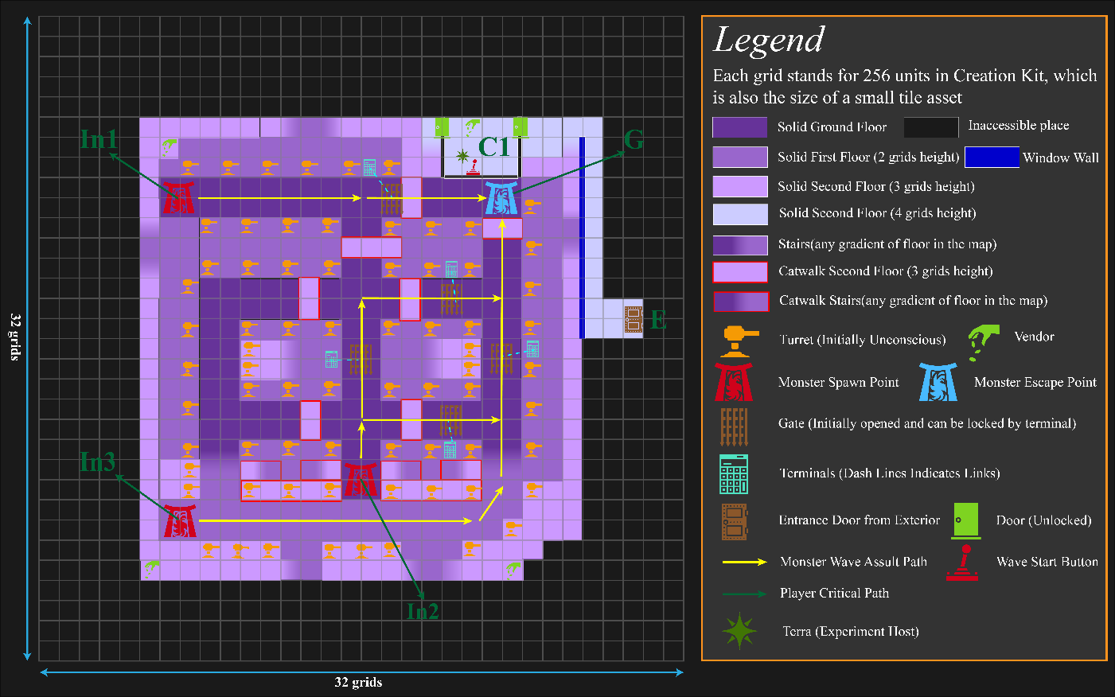



Figure : Walkthrough of Interior Experiment Field[3]

|  |  |  |
| --- | --- | --- |
| Map Label / Stage | Event Summary | Event Details |
| 1 | The Player reaches the experiment host | the player enters the interior space and reaches the place where the experiment host is |
| 2 | The player gains resources for the first wave | The player uses the caps givens by the experiment host to purchase ammos for custom weapon |
| 3 | The player sets up turrets for the first wave | The player uses the things bought from the vendor to set up the turret for the first wave |
| 3a (Repeated) | The player starts a wave | The player presses the button in C1 to start the next wave. (The player needs to repeat this step every time he/she wants to start a wave) |
| 4 | The player get the password of controlling the door from vendor | * A password costs 100 caps is now available to the player in the vendor. The player can buy it in order to gain control on all the gates in the level * Before wave 4, the player buys the password to close the gate A |
| 5,6,7,8 | * Player handles different waves till failures or end of the last waves * Open and close the gate B, C,D, E | * Escaping 10 enemies will cause the experiment to stop * The player closes or opens gates B,C, D, E according to his/her strategy * For critical solution in general before the last wave, gates A, B, C, D are recommended to close in sequence as:   + A is suggested to closed before wave 3   + B is suggested to closed before wave 5   + C is suggested to closed before wave 8   + D is suggested to closed before wave 10 |
| 9 | Talk to experiment host to finish the quest | * The player can stop the experiment and finish the quest by talking to the experiment host * The player report to the experiment host to finish the quest after all the waves finishes |

## Aesthetic References

The level takes place in a large modified underground vault. The decoration in this place is in a style mixing the vault technology style and industrial style providing bright and open space for path where the enemies in wave walking on and where the turrets are located.

For the control room, it is decorated with functional industrial machine lighted in white. It should look like a control room or an observation room where the researchers in this level took notes of their experiment.

### Experiment Field Decoration

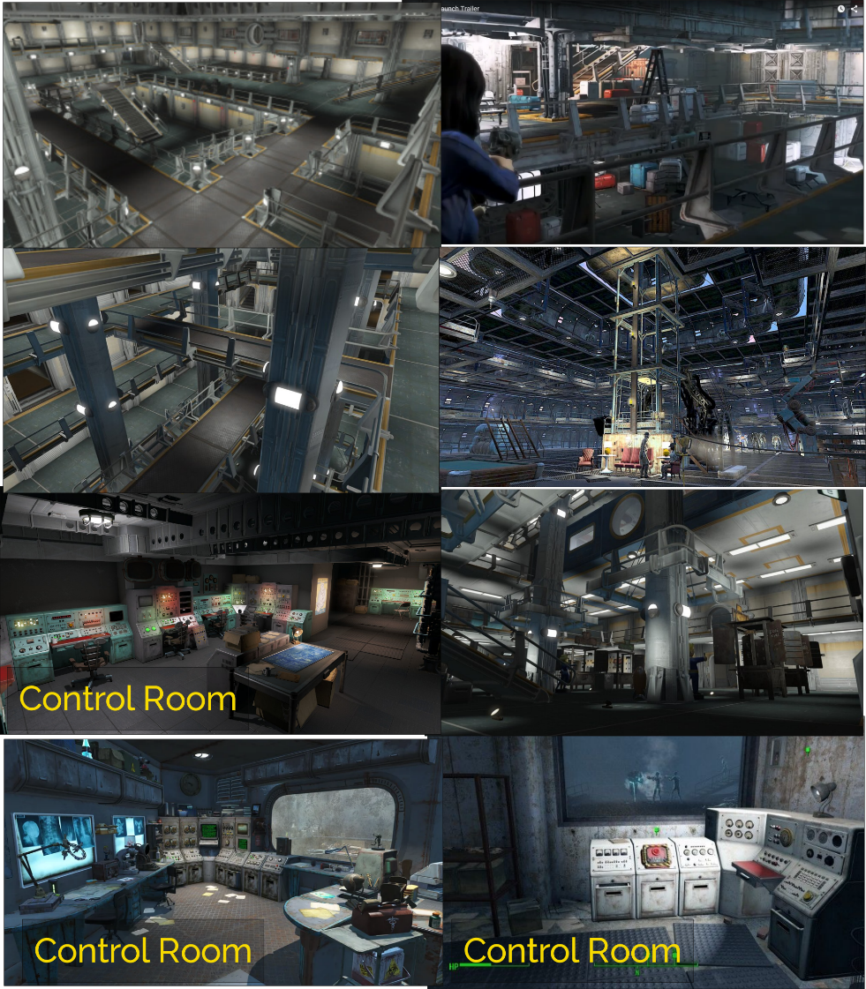

Figure Contact Sheet for Experiment Field Interior Decoration [2]

# References

[Cover Image] ZeusesCloud. *Starcraft 2 - Desert Tower Defense*. (Apr. 11, 2020). Accessed: May 24, 2023. [Online Video]. Available: <https://www.youtube.com/watch?v=-wi8NRERXc0>

[1] Li, Donghua, “Level Logic Flow Chart”, created by Diagrams.net, May. 22, 2023.

Li, Donghua, “Overview Map”, created by Diagrams.net, May. 22, 2023.

[2] Li, Donghua, “Contact Sheet for Experiment Field Interior Decoration”, created by Pureref, May. 22, 2023.

Gísli, “Artstation - fallout: Vault 13 | vault 13,” Fallout: Vault 13 - A recreation and reimagining of Fallout 1’s Vault 13, https://www.artstation.com/artwork/vJExDx (accessed May 23, 2023).

Chazzfizzle, “Dive into anything,” Reddit - A secret lab I’ve been building in the basement of Greater Mass Blood Clinic., https://www.reddit.com/r/fo4/comments/p9jadm/a_secret_lab_ive_been_building_in_the_basement_of/ (accessed May 22, 2023).

“Call to arms - main story, Brotherhood of Steel Quest: Fallout 4 Maps &amp; Quests,” Call to Arms - Main Story, Brotherhood of Steel Quest | Fallout 4 Maps &amp; Quests, https://mmo4ever.com/fallout4/quests/call-to-arms/ (accessed May 22, 2023).

P. sum qui Deum, “Dive into anything,” Reddit - Interior of another Vault? (From newest trailer), https://www.reddit.com/r/fo4/comments/3rnel8/interior_of_another_vault_from_newest_trailer/ (accessed May 22, 2023).

N. Shakespeare, “Fallout 4,” Nick Shakespeare, http://nickshakespeare.com/assorted-video-games/2018/9/26/fallout-4 (accessed May 22, 2023).

Khrushchev, “Screenshot :: Vault 88 residential area,” Steam Community, https://steamcommunity.com/sharedfiles/filedetails/?id=734151296 (accessed May 22, 2023).

“Vault 88 Mods - the best fallout 4 Vault 88 mods - top 10 best vault 88 mods,” Dirtyunicorns, https://dirtyunicorns.com/vault-88-mods/ (accessed May 22, 2023).

[3] Li, Donghua, “Overview Map”, created by Adobe Illustrator, May.28 , 2023.

Li, Donghua, “Walkthrough of Interior Experiment Field”, created by Adobe Illustrator, May.28 , 2023.

# Appendices

## Appendix A: New Skills / Gameplay Mechanics

**Note: All associated resources like ammos including the custom weapons themselves can be purchased from the merchant in the level by caps**

### <Mechanic A> Turret Activate Sniper

By shooting a turret with this gun, the player is able to activate a turret or disactivate a turret

For activating a turret:

* The turret will be activated as an Automated turret by default, which is the basic turret in the level
* When a turret is activated, it will be a level 1 turret
* When a deactivated turret is shot, it will become activated forever

For deactivating a turret:

* Deactivating a turret will make a turret unconscious
* Deactivating a turret will reset the type of a turret
* Deactivating a turret will reset the turret’s rank

### <Mechanic B> Turret Upgrade Sniper

* A turret can be upgraded when it’s shot by an upgrading ammo from player
* A turret picks its target by themselves
* A turret is invulnerable to player, or the player can only do little damage to the turret by this gun
* All turrets start in unconscious until it is activated

### <Mechanic C> Turret Type Changing Wrench

* The player can use the wrench to upgrade the turret by hitting it with this wrench
* For every hit, it will change the type of the turret for one time
* A turret can be in the flowing types:
  + Machinegun
  + Laser
  + Frozen

**<Mechanic D> Wave and Reward**

* As long as the wave starts, the player is allowed to have 10 enemies escape from the exit
* The player can get 50 caps every time an enemy in a wave dies
* Before the next wave starts, the player will have 5 minutes to do the management of the turrets. When the timer counts to 0, the next wave will start automatically
* The player can also start the wave manually by pressing a red button in the observation room

## Appendix B: Character Descriptions

### NPC 1: Raynor

|  |  |
| --- | --- |
| **Description** | * Quest Giver * Looking for people to help with the threshold experiment * 3rd – Gen Synth |
| **Background** | * Course of Institute |
| **Goals/Motivation** | * Find a helper for the threshold experiment |
| **Personality/Archetype** | * Cool * Loyal * Trustful |
| **Relationships** | * Helping the experiment holder looking for people to help with the threshold experiment |

### NPC 2: Terra

|  |  |
| --- | --- |
| **Description** | * Threshold Experiment Host * Human |
| **Background** | * Researcher of Institute Advanced Systems |
| **Goals/Motivation** | * Finish the Threshold Experiment |
| **Personality/Archetype** | * Smart * Calm * Trustful * Confident |
| **Relationships** | * The administrator of the underground experiment field * Boss of Raynor |

## Appendix C: Key Asset Needs

|  |  |  |  |
| --- | --- | --- | --- |
| Description | Editor ID | Type | Priority |
| Machinegun Turret MKIII, MKV, MKVII | 001A0065  001A0066  001A0067 | Actor | High |
| Laser Turret I, II, III | 001A854F  001A854D  001A854D | Actor | High |
| Frozen Turret I, II, III | 0019A7F2  0022B59D | Actor | High |
| Ghoul: Feral ghoul reaver, Withered feral ghoul, Gangrenous feral ghoul | 0007ED09  0007ED08  0011669E | Actor | High |
| Hound: Feral mongrel, Alpha feral mongrel, Glowing mongrel | 001324D9  001832FB  001324DC | Actor | High |
| Synth: Synth patroller, Synth seeker, Synth assaulter | 001A03F4  001A03F5  001A03F7 | Actor | High |
| Deathclaw: Deathclaw matriarch, Mythic deathclaw | 001423A9  001423AD | Actor | High |
| Pieces under: WorldObjects → Static → Interior → Vault | / | Modular Kits | Medium |
| Gate asset candidate: DN047FourLeafLabDoor, IndMetalDoorHuge | / | Door | Medium |
| Custom Weapon Base: LaserGun | 0009983B | Weapon | High |
| Custom Weapon Turret Activate Sniper, Turret Upgrade Sniper, Turret Type Changing Wrench | / | Weapon High | High |
| Vendor selling custom weapons and their ammos | / | Actor | High |
| Custom Ammo BaseAmmoFusionCell | 000C1897 | Ammo | Medium |
| Laser Turret III’s Skill Spell | / | Magic Effect | Medium |
| Frozen Turret I, II, III’s Skill Spell | / | Magic Effect | Medium |
| Notes for custom weapons | / | Book | Low |