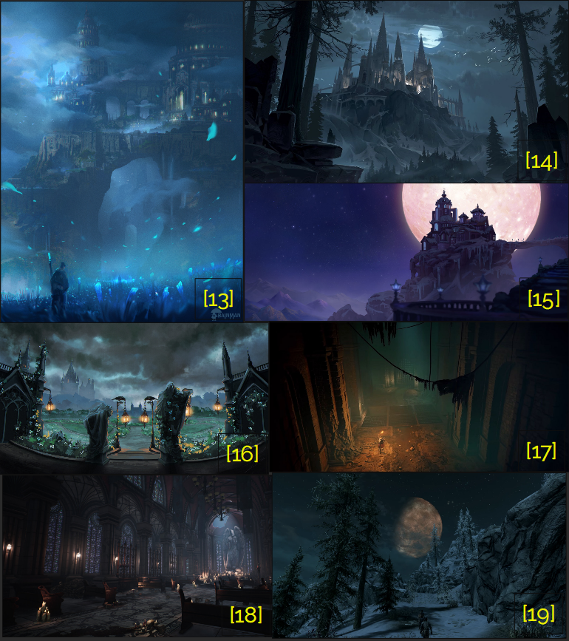

The Elder Scrolls V: Skyrim

Lunar Parchments
  - Version 3.0
Designer: | Donghua Elish Li
Document Date: | Sep 18, 2023
Intended Level Delivery Date: | March 4, 2024

Document Revisions Table
Version | Description | Requestor | Date
1.0 | Initial Document | Professor. Clark  Professor. Porter | July 14, 2023
2.0 | Final Document before pushing to become fully LDD | Professor. Clark  Professor. Porter | July 19, 2023
2.5 | LDD Interim focusing on layout improvement  Update 1: Castle Maps bring in layout changes  Update 2: Update Level Feature Overview in terms of Enemies, Player Skills | Professor. Clark | Sep 12, 2023
3.0 | LDD Complete Version  Update 1: Bring in traps and ambush  Update 2: Dominions’ adjustment  Update 3: Fixed Typos  Update 4: Castle Sentry Tower Second Floor layout  Update 5: Rebalance Enemies amount  Update 6: Skill Progression Chart | Professor. Clark | Sep 19, 2023

Table of Contents
Table of Contents 3
Table of Figures 4
Level Summary 5
Quick Summary 5
Level Feature Overview 5
Development Schedule 6
Level Details 7
Level Map(s) 7
Overview Map 7
Details Map(s) 9
Skill Progression Chart 16
Appendix A: Aesthetic References 17
Theme : Sewer 17
Theme: Mixing style of Castle and Academy of Magic 18
Appendix B: New Skills/Gameplay Mechanics 18
Appendix C: Context 19
Backstory 19
Aftermath 19
Appendix D: Characters/Dialog Flow 20
Character 1: Urani (Princess Luna, the mysterious old wizard) 20
Appendix E: Risks 21
Appendix F: Key Asset Needs 21
References 22

Table of Figures

Figure 1 Overview Map[12] 7
Figure 2 Overview map of castle' names [12] 7
Figure 3 Dominion Partition [12] 8
Figure 4 Legend [12] 8
Figure 5: Walhthorugh of Path of the moon light [12] 9
Figure 6: Walhthorugh of Front Gate [12] 10
Figure 7: Walhthorugh of Cliff Path [12] 11
Figure 8 Walhthorugh of castle tower 2nd floor [12] 12
Figure 9: Walhthorugh of the Main Castle first part [12] 13
Figure 10: Overview Map of Chapel the Moon 2nd floor [12] 14
Figure 11 Walkthrough of the main castle second part [12] 15
Figure 12 Skill Progression Chart [19] 16
Figure 13 Art style reference of the cave and sewer part for the castle 17
Figure 14 Art style reference of Castle exterior and its interior 18

Level Design Document

Level Summary

Quick Summary
The standalone quest, Lunar Parchments, is a single-player non-linear miniscape level created by minimal logic map derived by graph theory, played in The Elder Scroll V: Skyrim. In this level, the player is going to seek at least 3 magic parchments out of 7 hidden in a castle in the magic forest without the assistance of any NPCs excepting the quest giver. It notes that the quest giver is not going to tell the player the total amount of parchments in the castle, but she will encourage the player to gather as many as possible narrative-wise.
This level aims at testing whether the player can find directions of goals and maintain a good enjoyment of exploring the level. To guide the player to a flow completing this non-linear level, level design techniques are also implemented to help the player identify it and main objectives. The player is expected to fight with creatures in this level via physical combat and overcome the challenges brough from lack of magicka. The player can still do magic but the reduced maximum magicka limits it.

Level Feature Overview
Category | Sub-Category | Feature List
Player | Player Weapons | - Shield  - Lunaric Magic Sword (Custom weapon)  - Bows
 | Player Skills/Abilities | - Using Shield to block attack  - Stealth attack enemies  - Disarm Traps
AI | Enemies | - Wolf  - Bear  - Skeleton (Melee, Ranged)  - Draugr (Melee, Ranged, Scourge)  - Hagravens
 | Friendlies | - Urani (quest giver)
Challenges | Gameplay Themes | - Management of Stamina and limited magicka  - Block and attack  - Use bows to take down enemies one by one
 | Obstacles/Hazards | - Elemental Rune  - Flamethrower
 | New/Unique Gameplay | N/A
Context | Where Fits in Game | - Narrative-vise, the level tells a story about of a magic disaster happening in the past by notes and environment storytelling. NPCs will not be active at telling story  - The player get access to the small world by enter a magic barrier protecting the castle
 | Challenge Fit | - The level provides challenges of in-contact combat against different creatures without using spell  - It is a standalone quest in the Skyrim world  - The level provides challenges of completing the level in a lower magicka situation. They player will enter the level with 10% maximum magicka until he leave this level. Or, for each parchment the player collect, he will recover 10% maximum magicka
 | Additional Info | - The Lunaric sword given by the quest giver will gain additional damages whenever the player gains a parchment  - If the player collected all the seven parchments at the end, the player is able to learn a new spell that allows the caster to obliterate a target immediately by consuming 99% magicka and health point.
Aesthetics | Major Visual Themes | - Castle  - Sewer  - Chapel
 | Setting/Mood | - Mysterious  - Decay  - Holy

Development Schedule
Milestone | Date
LDD | Sep 19, 2023
Whitebox | Oct 3, 2023
Initial Gameplay | Oct 31, 2023
Gameplay Complete | Nov 28, 2023
Aesthetics | Jan 30, 2024
Launch | Feb 6, 2024

Level Details

Level Map(s)

Overview Map
Note: This is a generally map conveying how different parts of the level are connected with each other
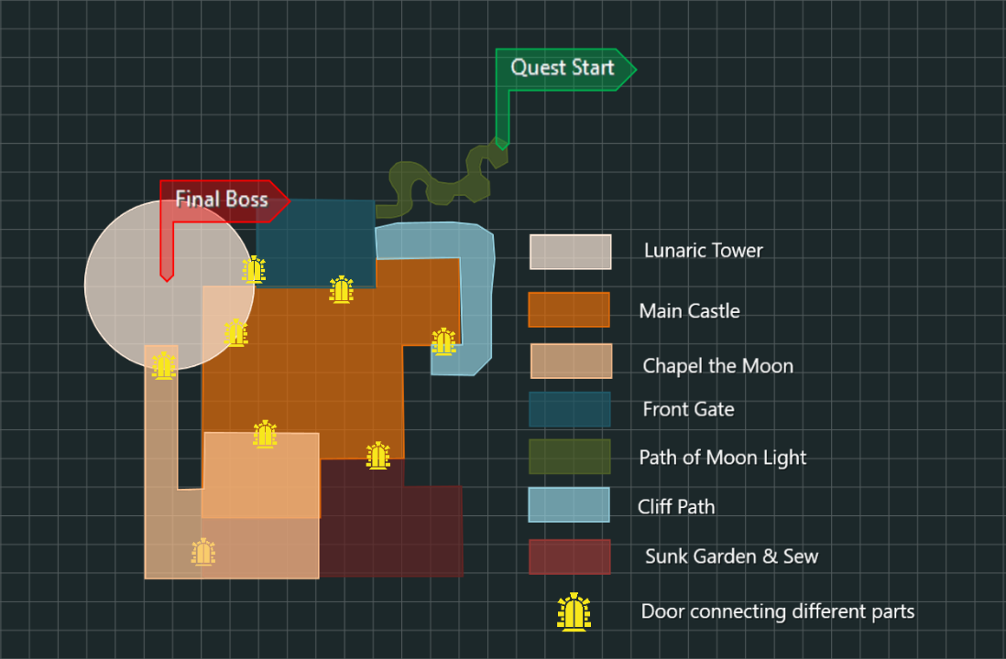
Figure 1 Overview Map[12]
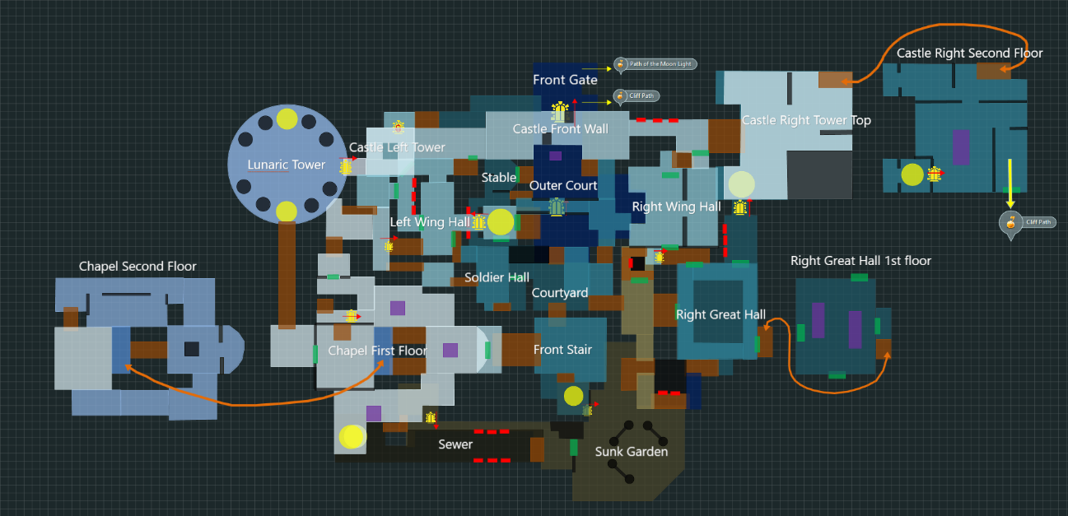
Figure 2 Overview map of castle' names [12]
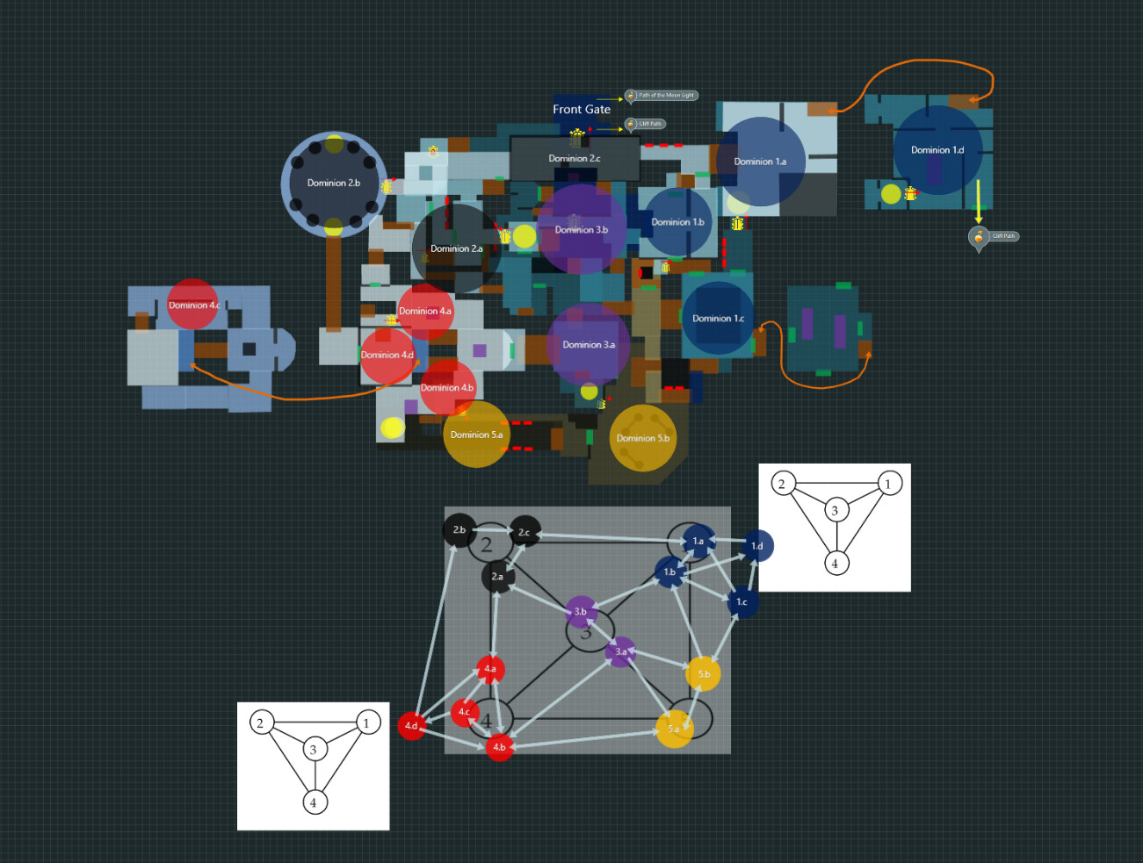
Figure 3 Dominion Partition [12]
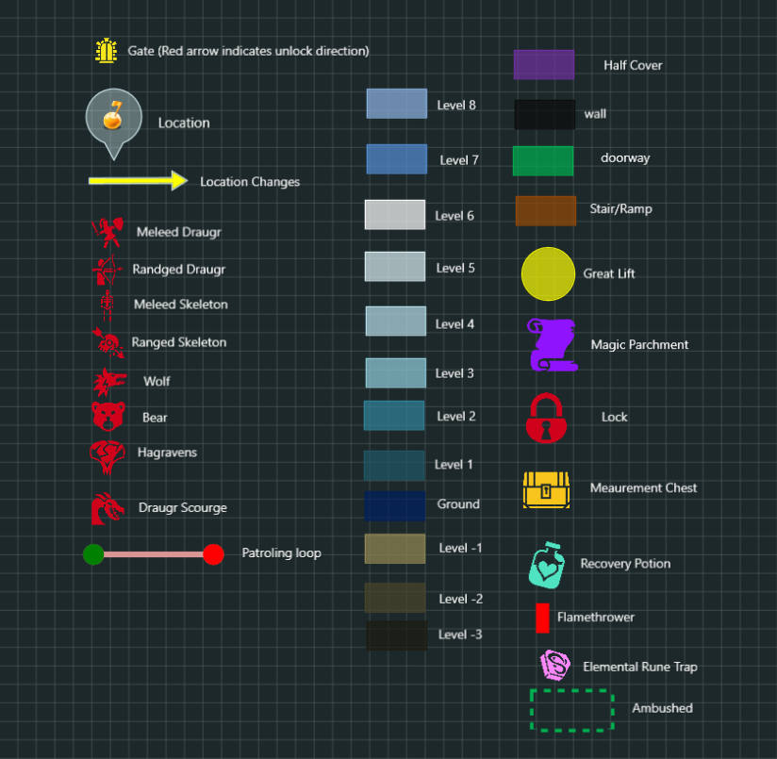
Figure 4 Legend [12]

Details Map(s)
Note:
- This is a standard walkthrough for collecting all parchments which are designed as a measurement of the hypothesis at once without spending extra time to exploration around the level.
- The second and third measurement of exploration will be the amount of unlocked directional doors and looted chest box hidden in the whole castle part
- To complete the quest, the player need to gain at least 3 parchments while gathering all the parchments is a optional objective.
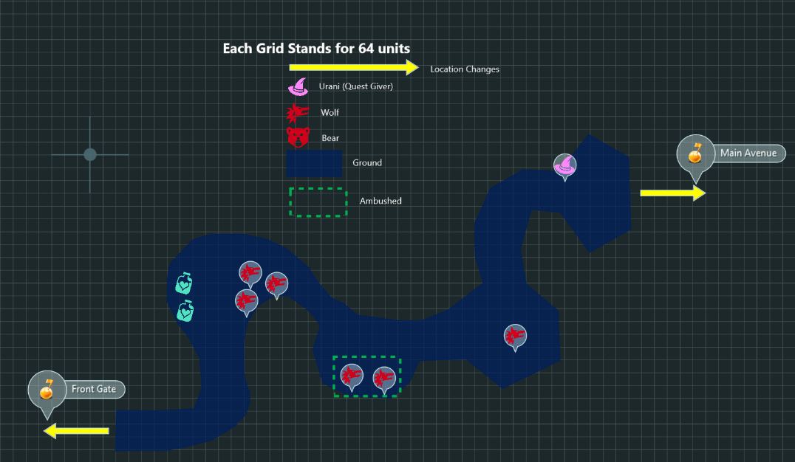
Figure 5: Walhthorugh of Path of the moon light [12]
Map Label | Gameplay Summary | Other Notes
1 | Accept the quest from the quest giver Urani | The player gains start-up weapon and get information about the objectives and backstory
2 | Go along the forest path and defeat the enemies along the way | N/A

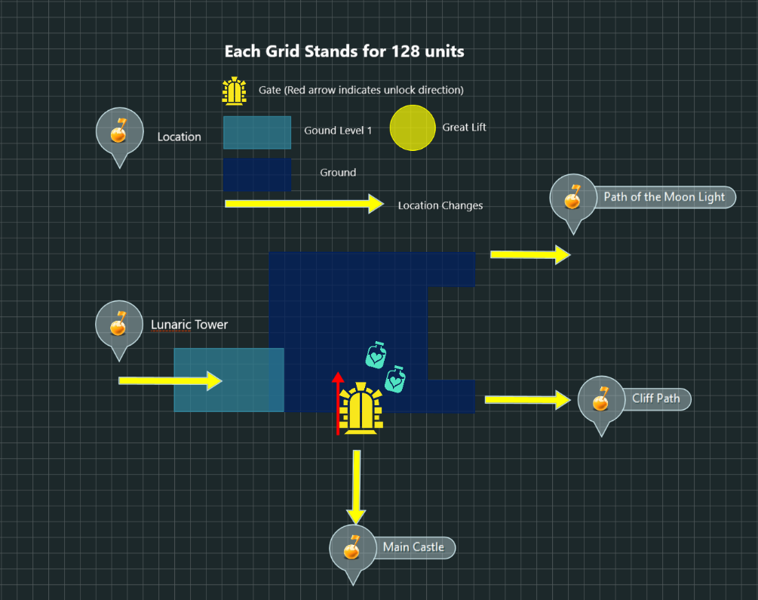
Figure 6: Walhthorugh of Front Gate [12]
Map Label | Gameplay Summary | Other Notes
3 | Go down to the Front Gate and go to the cliff path | - For flow control, the gate i is locked until the player unlocked them from the other side. It will also be unlocked when the final boss is defeated  - The higher ground from Lunaric Tower is too high to jump from the ground for the player
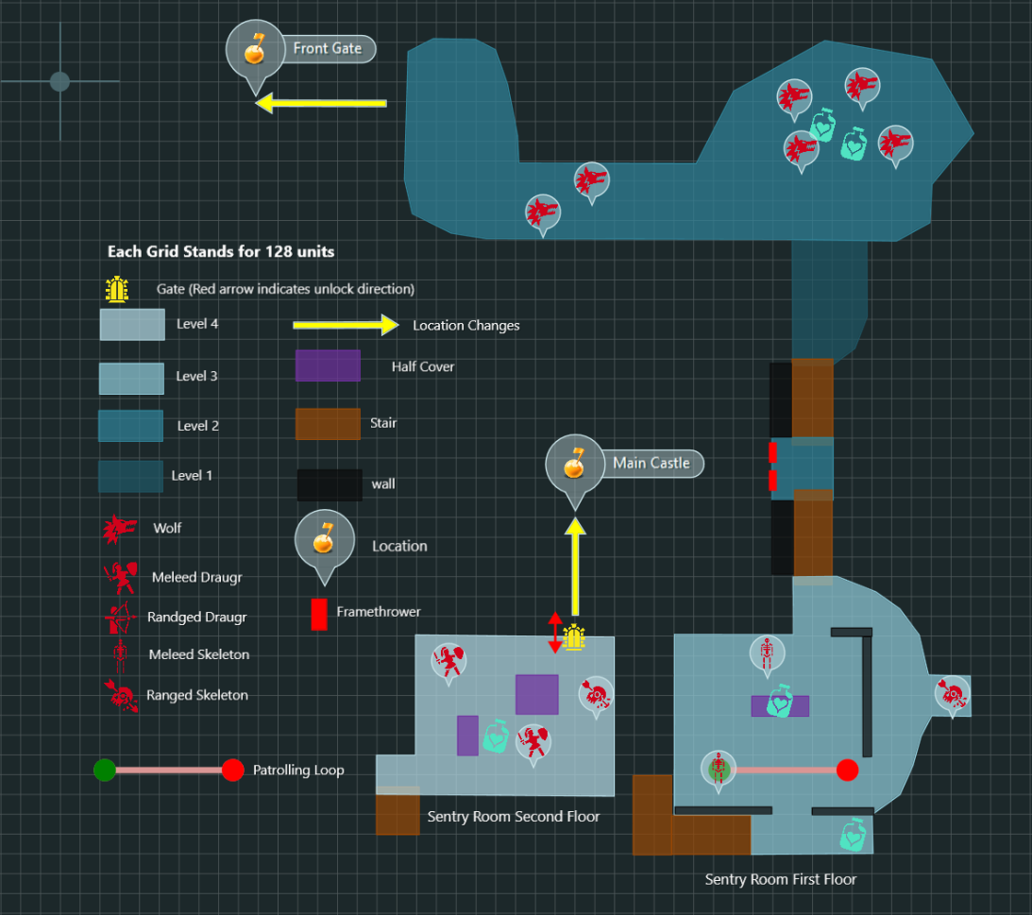
Figure 7: Walhthorugh of Cliff Path [12]
Map Label | Gameplay Summary | Other Notes
4 | Go along the cliff and defeat the enemies along the way | N/A
5 | Jump down and climb the ramp. Dodge or disarm the flamethrower on the wall and reach the top of the ramp | N/A
6 | Get into the first floor of the sentry room and defeat the enemy there to go to the second floor | N/A
7 | Defeat the enemies at the second floor and open the door to get into tower second floor | N/A
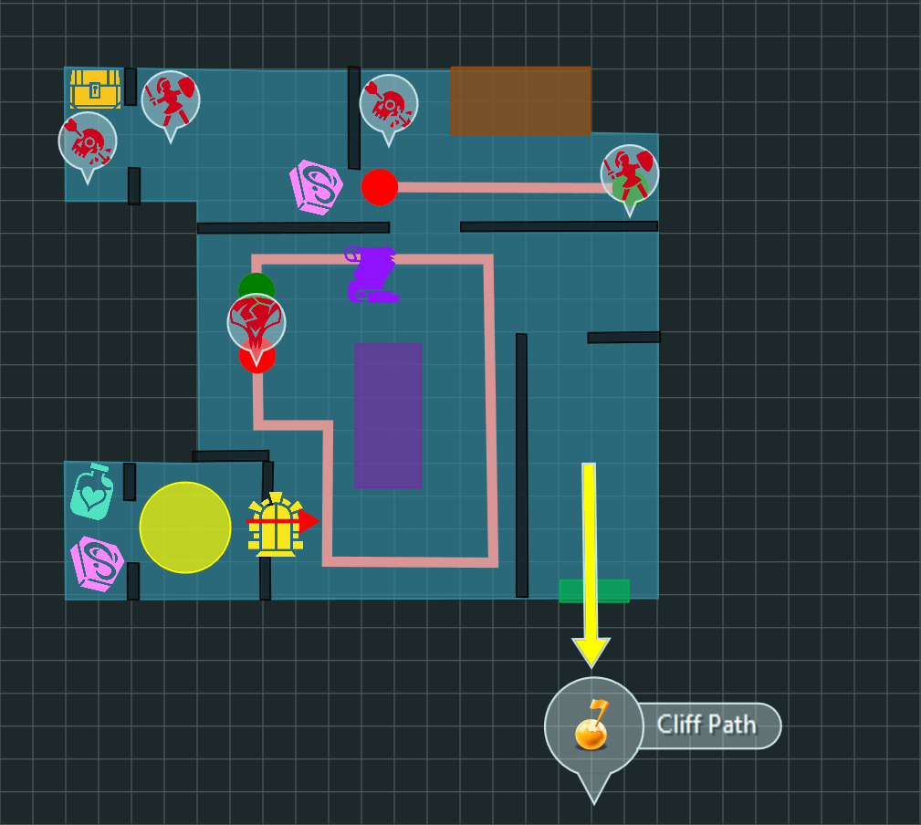
Figure 8 Walhthorugh of castle tower 2nd floor [12]
Map Label | Gameplay Summary | Other Notes
8 | Move forward and turn left to enter the hall | N/A
9 | After defeating the mini boss in the middle of the hall and the enemies blocking the way to the stairs, climb up the stairs to move on to the tower top | First parchment retrieved
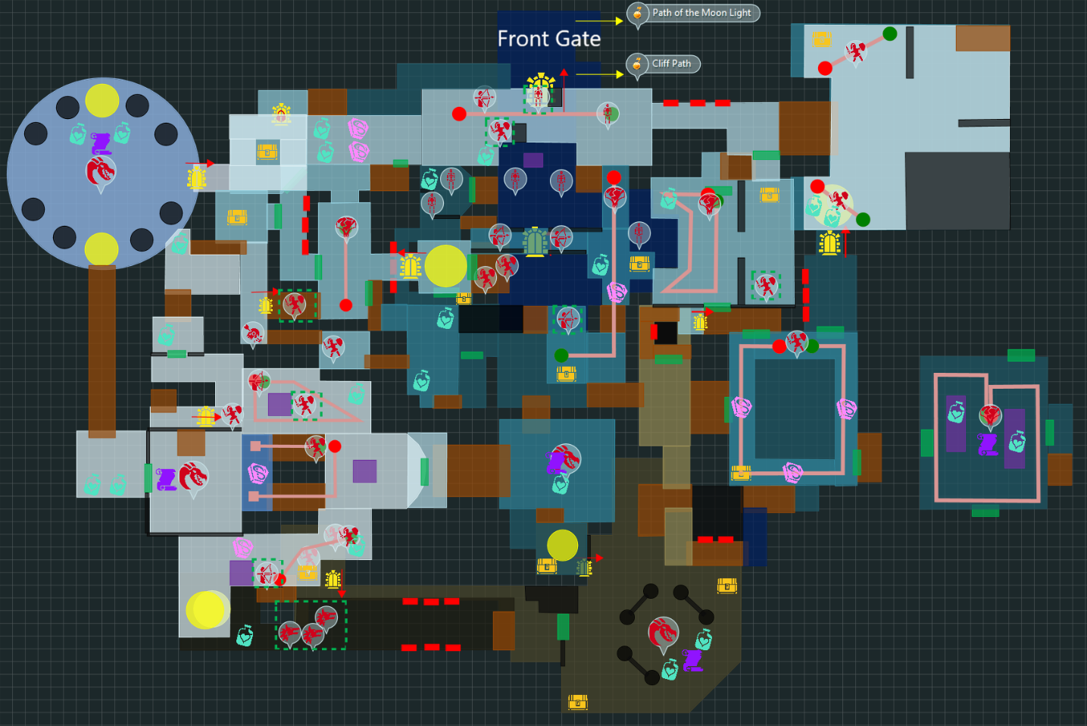
Figure 9: Walhthorugh of the Main Castle first part [12]
Map Label | Gameplay Summary | Other Notes
10 | Reach the third floor, go downstair | N/A
11 | Move forward along the Castle Front Wall and defeat the enemies along the way. Then, go downward from the left stairs at the end | N/A
12 | Make a left turn to enter the Left Wing Hall. Defeat the Hagraven and ambush enemies there. Then Move forward and use the stairs at the left exit doorway to move forward to the Soldier Hall. Use the stairs at the end of the hall to move downward to the Courtyard | N/A
13 | Make a right turn and go upstairs to reach the Front Stairs. Defeat the Draugr Scourge there | Second parchment retrieved
14 | Use the stairs at the end of the Front Stairs area to go downward. Take the elevator to go to the Sunk Garden. Go to the middle of the Sunk Garden and defeat the Draugr Scourge there. | Third parchment retrieved
15 | Use the stairs at the north of the Sunk Garden to go upward. At the end of the stairs, get into the Right Great Hall and defeat the Hagraven there | Forth parchment retrieved
16 | Left the Right Great Hall from its front stairs and return to the Courtyard. Climb the same stairs to go to the Front Stairs. Make a left turn to climb on the stairs to enter the Chapel First Floor | N/A
17 | Defeat the enemies patrolling on the stairs of the chapel, go upstairs to the second floor | N/A

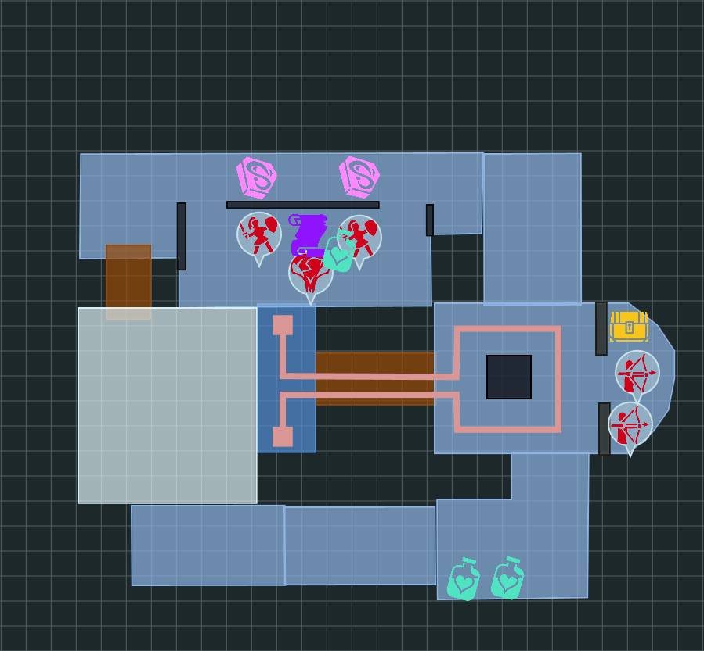
Figure 10: Overview Map of Chapel the Moon 2nd floor [12]
Map Label | Gameplay Summary | Other Notes
18 | After reaching the second floor, make a left turn and defeat the Draugr and Hagravens there | Fifth parchment retrieved
19 | Turn around and go back the hall near the stairs and go forward to the southern side of the hallway. Defeat the Draugr along the way. At the end of the hallway, jump down to the central hall in the first floor | N/A
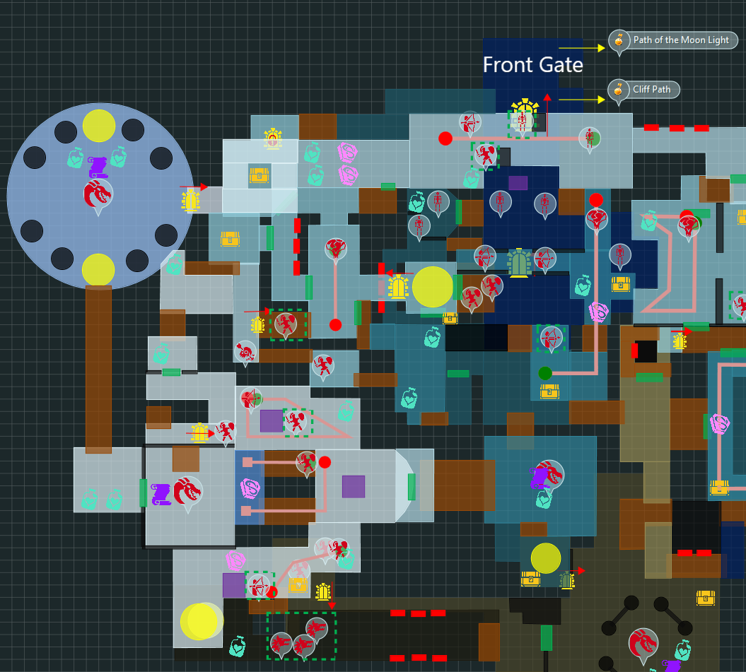
Figure 11 Walkthrough of the main castle second part [12]
Map Label | Gameplay Summary | Other Notes
20 | After landing on the ground, defeat the Draugr Scourge in the central hall. After that leave here from the exit at the west side | Sixth parchment retrieved
21 | Make a right turn and go along the long stairs to climb to the entrance of the Lunaric Tower. Take the elevator there to reach its top floor. Defeat the two Draugr Scourges there | Seventh parchment retrieved
22 | After the fight, take the elevator at the other side to climb down the tower. Leave the tower from a gate at its east side. Jump into the pit in the middle of the Castel Left Tower | There is a key that is required here. The key is retrieved by defeating the to Draugr at the top floor of the Lunaric Tower
23 | Use a key retrieved at the top of the Lunaric Tower to unlock the door in the Castle Left Tower. Leave the castle from the door and return to the front gate. The quest giver will be there waiting for the player to complete the quest | N/A

Skill Progression Chart
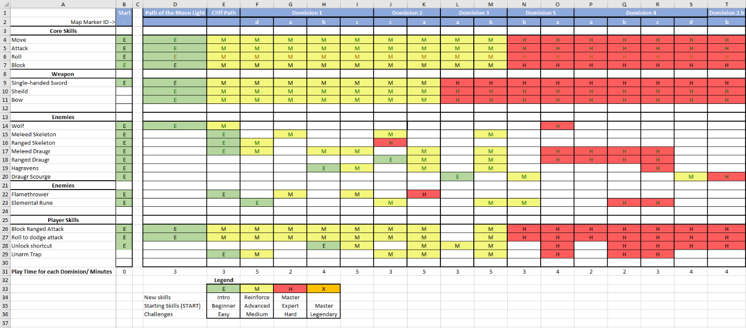
Figure 12 Skill Progression Chart [19]
Note:
- Because the level is non-linear, the skill progression cannot reflect precisely how a player’s skills progress in terms of small spaces or areas in each dominion. However, the skill progression among different dominions can reflect how the player’s skills progress in the level.
- The cumulated player time is not estimated according to a linear flow. Instead, the play time for a single dominion are estimated.

Appendices

Appendix A: Aesthetic References

Theme : Sewer
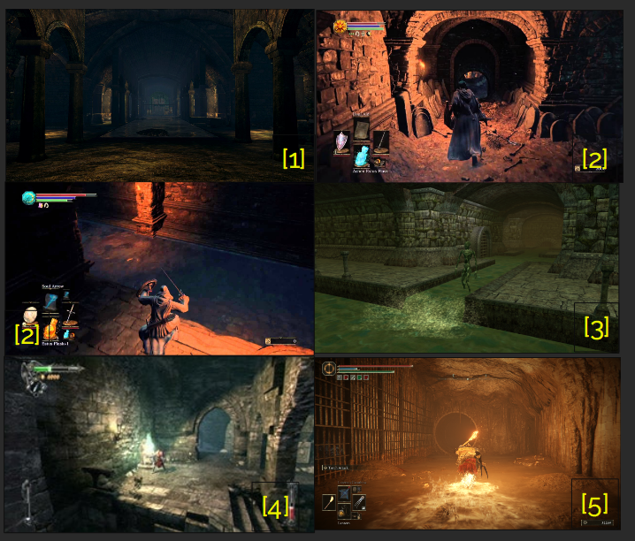
Figure 13 Art style reference of the cave and sewer part for the castle

Theme: Mixing style of Castle and Academy of Magic
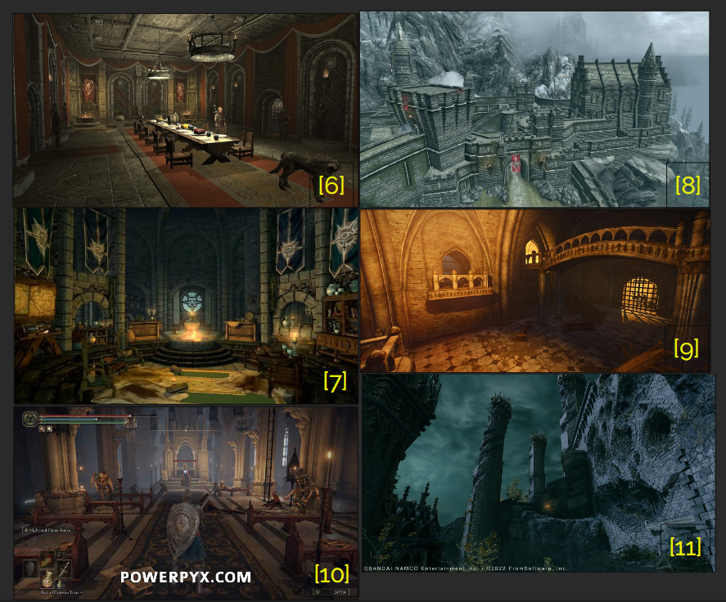
Figure 14 Art style reference of Castle exterior and its interior

Appendix B: New Skills/Gameplay Mechanics
N/A

Appendix C: Context
The standalone quest, Lunar Parchments, takes place in an abandoned ancient castle constructed by the lake of The Lunar. It is why residents around it called it Castle Lunaria in the past. On the forest path along the giant plants covering the high wall of Lunaria, the player will meet a mysterious old wizard telling him that there are seven magical parchments hidden in the castle. Whoever gathers all of them can learn a powerful ancient spell. She asks the player to find it but also to take care of the creatures that dominates that place.
It is important to notice that, except for the quest giver, there is not any other NPCs who tells the player about the goal and information about the quest. Exploration experience is given by notes related to the story of this castle and the past story.
To finish the quest, the player needs to collect at least three magical parchments. The main objective will tell the player that 3 parchments are required to help Urani while an optional objective will tell that if all parchments are collected, the player can learn a special spell as a reward.

Backstory
Princess Luna was the lord of Castle Lunaria when it flourished in the days before. But an unexpected magic phenomenon attacked this place and then, all the residents around this area disappeared after the light, covering the whole area, faded out. No one know what happened exactly at that time, but this phenomenon changed the castle to become a well-spring of mana, attracting dangerous creatures to be the new its new lord.
The magic phenomenon is actually an accidence caused by Princess Luna’s research when she was creating a new spell using an ancient volume of magic parchments. After that magic phenomenon, the remnant of the volume absolved all lives together with their magicka around the castle and become a well-spring of magicka.
In this artifact, this is the story that the player can find by reading the notes written by the people who lived in the castle in the past before that phenomenon.

Aftermath
If the player collects all the seven parchments before returning to the quest giver, the player is able to learn a new spell that allows the caster to obliterate a target immediately by consuming 99% magicka and health point. But the player cannot find the old prophet Urani who introduced the parchment at the entrance of the forest except for her cloths and items including a ring that allows its equipper to regenerate mana quickly at night.

Appendix D: Characters/Dialog Flow

Character 1: Urani (Princess Luna, the mysterious old wizard)
Description | The phantom generated by the remnant of Princess Luna
Background | Princess and lord of the Castle Lunaria
Goals/Motivation | Find someone to free the castle from dangerous creatures attracted by the parchments and return peace and silence to this area
Personality/Archetype | confident, elder, wise
Relationships | N/A

Appendix E: Risks
Map Label | Description/Mitigation | Type | Priority
R1 | Missing of art modular pieces  Mitigation: Texture swapping on assets that can replace the missing piece | Mesh | Medium

Appendix F: Key Asset Needs
Description | Type | Priority
A magic spring set that is static. It acts as a save point providing health supply and auto save | Script | High
Great Lift | Script | Medium
Lunaric Magic Sword | Script | Medium
A huge door locked by enchanted shield | Script & FX | Low
Death trigger killing creatures including player for dead cliff | Script | Medium
Lunar Ring | Script Item | Low
Lunar Parchment Spell | Scripted Magic Effect | Low

References
[1] “Depths,” Dark Souls Wiki, https://darksouls.fandom.com/wiki/Depths (accessed Jul. 14, 2023).
[2] Diabetic Man, “Dark soulsTM III: Grave key (sewers),” YouTube, https://www.youtube.com/watch?v=AXdXXH5AV-g (accessed Jul. 14, 2023).
[3] Ancarion, “Castle sewers,” Castle Sewers | The Neverwinter Vault, https://neverwintervault.org/project/nwn1/hakpak/tileset/castle-sewers (accessed Jul. 14, 2023).
[4] S. Lee, “Walkthrough (Chapter Five) part 20 - castlevania: Lords of shadow guide,” IGN, https://www.ign.com/wikis/castlevania-lords-of-shadow/Walkthrough_%28Chapter_Five%29_part_20 (accessed Jul. 14, 2023).
[5] M. Jackson, “Elden Ring Review,” Knight Errant, https://bsmknighterrant.org/2022/05/06/elden-ring-review/ (accessed Jul. 12, 2023).
[6] A. Ato, “Forspoken - Visoria Castle Caves,” Artstation, https://www.artstation.com/artwork/NywwqJ (accessed Jul. 12, 2023).
[7] R. RaidyHD, “Wallpaper : The elder scrolls v skyrim, water, cave, video games, atmosphere, low light 1920x1080 - RAIDYHD - 1942151 - HD Wallpapers,” WallHere, https://wallhere.com/en/wallpaper/1942151 (accessed Jul. 12, 2023).
[8] S. Turner, “Soul cave - lighting,” Stephen Turner Art, https://stephenturnerart.com/projects/8l66oE (accessed Jul. 12, 2023).
[9] jasperthegnome, “Screenshot :: New Project - Tiny Cave with garden,” Nexus Mods :: Skyrim, https://www.nexusmods.com/skyrim/images/603961 (accessed Jul. 12, 2023).
[10] Gage, “Elden Ring Academy of raya lucaria walkthrough,” PowerPyx, https://www.powerpyx.com/elden-ring-academy-of-raya-lucaria-walkthrough/ (accessed Jul. 12, 2023).
[11] Upsurge Studios, Artstation - Elden Ring: Stormveil castle, https://www.artstation.com/artwork/LexEOP (accessed Jul. 12, 2023).
[12] Level Maps, created by Donghua Elish Li in Articy Draft 3, July 14, 2023.
[13] R. Page, “hidden castle,” Artstation, https://www.artstation.com/artwork/LAXbv (accessed Jul. 17, 2023).
[14] MOB.org, “Desktop HD Wallpaper: Fantasy, night, Moon, castles, Castle Free Download background picture #482282,” HD desktop wallpaper: Fantasy, Night, Moon, Castles, Castle download free picture #482282, https://wallpaper.mob.org/pc/image/fantasy-castle-moon-night-482282.html (accessed Jul. 11, 2023).
[15] F. P. Marion, “The moon castle - Another piece from a school project.,” Artstation, https://www.artstation.com/artwork/lK135 (accessed Jul. 17, 2023).
[16] E. Bican, “Gardens,” Artstation, https://www.artstation.com/artwork/1xZ1Wq (accessed Jul. 17, 2023).
[17] P. Bagaria, “Elden ring trick lets players skip part of sewers,” Game Rant, https://gamerant.com/elden-ring-skip-sewers-how/ (accessed Jul. 17, 2023).
[18] N. Mendoza, “Cathedral of the Dead - CGMA Modular Environment Course,” Artstation, https://www.artstation.com/artwork/8lVn5q (accessed Jul. 7, 2023).
[19] Li, Donghua, “Skill Progression Chart”, created by Microsoft Excel, Jul. 19, 2023.

