

Half-Life 2: One Way Out
  - Version 1.0
Designer: | Donghua Li
Document Date: | 10/31/2022
Intended Level Delivery Date: | 12/5/2022

Document Revisions Table
Version | Description | Requestor | Date
1.0 | Initial Document | Professor Ouellette | 31/10/2022

Table of Contents
Table of Contents 2
Table of Figures 3
Level Information 4
Quick Summary 4
Level Feature Overview 4
Level Map(s) 6
Overview Map 6
Section 1: Seek a way in 8
Section 2: Thematical Break-in 9
Section 3: Sawblades and Zombies 10
Section 4: Zombie Cutter 11
Section 4a: Ignition 12
Section 5: Bullet Rain 13
Section 6: Bypass the Emplacement Gun 15
Section 7: Rescue 16
Section 8: Way out 17
Skill Progression Chart 17
New Skills/Gameplay Mechanics 18
Hook(s)/Gameplay Highlights 19
Context 19
Backstory 19
Aftermath 19
Development Schedule 19
Aesthetic References 20
“One Way Out” Contact Sheet 21
Unique Requirements and Risks 22
Key Asset Needs 22
References 23

Table of Figures

Figure 1: Overview Map [1,2,3] 6
Figure 2: Seek a way in Overview Map [1,2,3] 8
Figure 3 Thematical Break-in Overview Map [1,2,3] 9
Figure 4 Sawblades and Zombies Overview Map [1,2,3] 10
Figure 5 Zombie Cutter Overview Map [1,2,3] 11
Figure 6 Ignition Overview Map [1,2,3] 12
Figure 7 Bullet Rain Overview Map [1,2,3] 13
Figure 8 Bypass the Emplacement Gun Overview Map [1,2,3] 15
Figure 9 Rescue Overview Map [1,2,3] 16
Figure 10 Way Out Overview Map [1,2,3] 17
Figure 11 Skill Progression Chart [3,4] 17
Figure 12 One Way Out Contact Sheet [5 - 12] 21

Level Design Document

Level Information

Quick Summary
One Way Out is a side-story that happened before Gordon Freeman returns to the City 17 in the chapter 10 “Anticitizen One”. Dr. Gordon is going to free the forced labors in the sawblade factory in the forest in order to expand the citizen’s troop. Therefore, Dr. Gordon needs to get access to the central controller observation unit to open the gate of the factory so that the citizen troops can rescue the workers. Sawblade is the product that is made in this factory, and Dr. Gordon will be able to find a new way to use the sawblade to fight with the enemies with gravity gun
It is a single-player level with an expected experiencing time span about 5-10 minutes. In the level the player will notice and learn that a thematical sawblade, which is a sawblade that is heated to high temperature, is able to penetrate grating wall, as well as combine covers if it is punched by the gravity gun. Hence, the level combat will encourage the player to use the thematical sawblade to take down enemies that hides behind combine walls. It promotes a play style where the player hide and shot the enemies that is in short range while using a thematical sawblade to take down those hide behind the cover in far range. What’s more, a thematical sawblade also functions in affecting the conducive rate of electricity on metal circuit panel, which is helpful when it is going to disactivate the lock down of the factory’s guard system.

Level Feature Overview
Category | Sub-Category | Feature List
Player | Player Weapons | - Gravity Gun  - Shotgun
 | Player Skills/Abilities | - Punching thematical sawblade to hit entities behind grating wall  - Heating sawblade to be thematical sawblade  - Stop electricity conduction  - Penetrate Combine Wall to take down  - Use thematical sawblade to ignite wooden bracket
AI | Enemies | - Zombie  - Combine Soldier  - APC
 | Friendlies | - Citizens
Challenges | Gameplay Themes | - Overheated thematical sawblade can penetrate thin metal obstacles and combine wall  - Overheated thematical sawblade can stop electricity conduction
 | Obstacles/Hazards | - Electricity circuit panel  - Combine with emplacement Gun  - Electricity circuit puzzles (Unlock doors for puzzle room)
 | New/Unique Gameplay | - Thematical Sawblade, which can penetrate thin grating wall, penetrate combine walls, ignite wooden brackets, and stop electricity conduction  - Electricity Logic Gate Doors Controller (Puzzle)
Aesthetics | Setting (visual theme) | - In general, it is an automatic sawblade production factory in the forest region  - For area 1, it is a wrecked warehouse near the factory which is possessed by zombies  - For area 2, it is a sawblade workshop of the factory

Level Map(s)

Overview Map
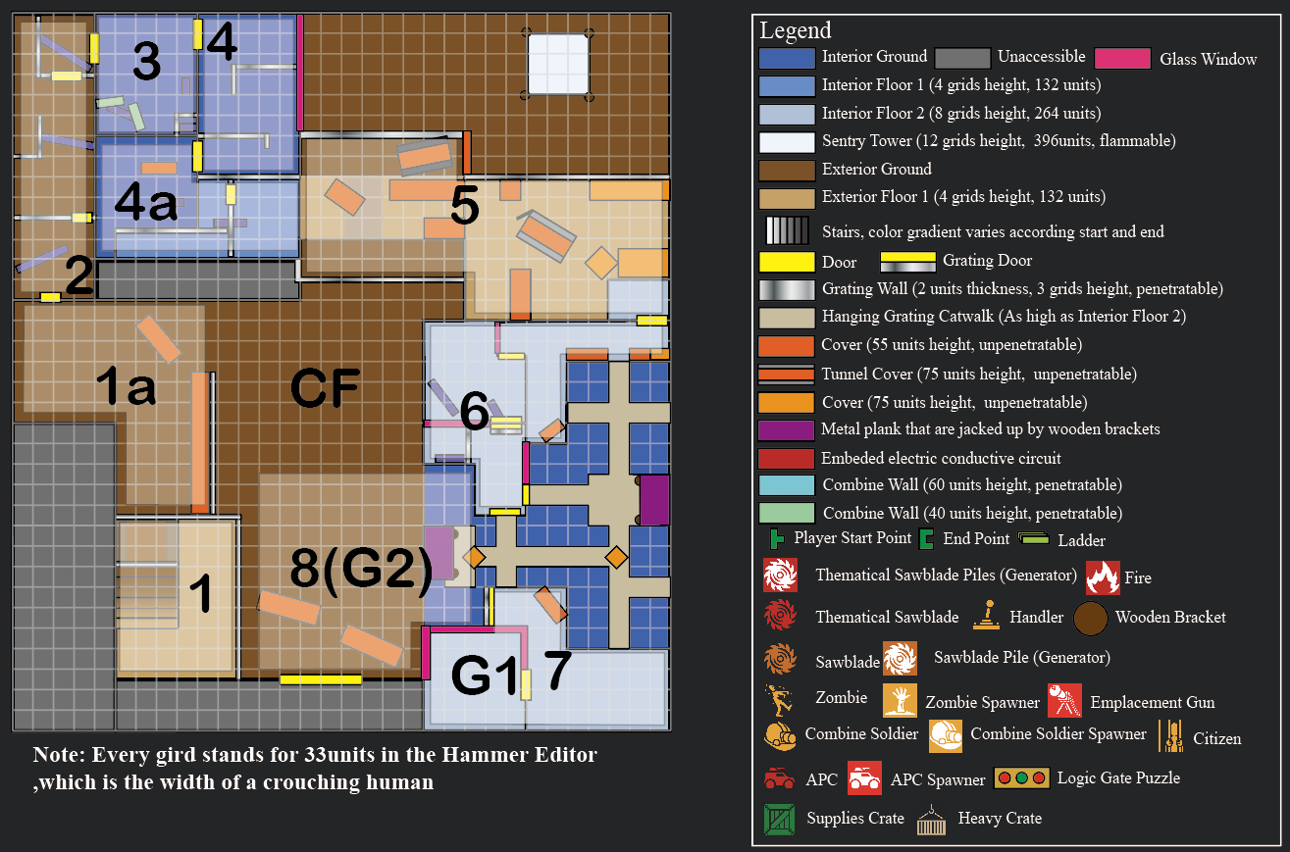
Figure 1: Overview Map [1,2,3]
Map Label | Gameplay Summary
1 | Outdoor area, the player starts here and facing the sawblade workshop unit where the Section 6 and 7 are and knows the goal is the room G1. In additional, the player is able to know that the front gate is guarded by 3 combine emplacement gun.  - The player crouches and walks down the stairs and leave this section.
1a | It is the outdoor walkway toward the section 2. The combat field of zombie and combine CF emphasizes that it is dangerous to go through this area and the player is informed that there should be another entrance.  - The player crouches and walks toward the door of section 2 and leave this section
2 | Section 2 is an outdoor area where the player is going to learn about the thematical sawblade properties that it is able to penetrate grating wall, it will cool down after hitting something, hitting a electric circuit panel can keeps it thematical, and it is able to stop electricity conductivity. The electricity circuit panel is also taught to the player that it will electrify the grating wall keeping the player away from opening the grating door.  - The player enters this section from the door and see that an aggressive zombie is killed by the electric circuit panel on panel  - Right after the player goes through the door, small debris are drop from the left and right onto the burning thematical sawblade on the ground. Thematical sawblades are blew out and kill the zombie behind the grating wall after penetrating it  - The player goes ahead and see an electric circuit panel is disactivated by a thematical sawblade  - The player sees a grating wall is electrified by the circuit panel. The player disactivates it and open the grating door and leave this section
3 | Section 3 is an indoor puzzle room where the player is going to learn what can be penetrated by the thematical sawblade while solving the puzzle. The puzzle is a logic gate puzzles related to the electric circuit panels on wall or on floor. The player also learns that a normal sawblade can change to a thematical one after being heated by fire.  - The player heats 3 normal sawblades by fire and punch them to electric circuit panels in a way that solving the puzzle  - The player leave this section
4 | Section 4 is an indoor combat room where the player is going to practice the learnt skills by fighting several zombies  - Using the thematical sawblades as well as shotgun, the player clears the room and leave it
4a | Section 4a is an indoor subsection of section 4. The player is going to learn that the thematical sawblade can ignite heavy wooden bracket so that the heavy props on the planks it supports will drop down. A combine solider appears in this section informing the player that there will be combats to combine solider in the later sections  - The player uses the thematical sawblade to ignite the wooden brackets in order to drop the heavy block the entrance where the zombie comes in  - The player uses the thematical sawblade to penetrate the grating wall and kill the combine solider soldier coming in from the direction of section 5  - The player ignites the wooden brackets to drop the metal plank and the player stops the electric circuit panel by thematical sawblades  - The player leaves the section
5 | Section 5 is an outdoor combat area where the player experiences the combat with combine while using the thematical sawblade and the shotgun. The player will also encounter combine emplacement gun from a ranged sentry tower.  - The player crouches and moves forward to the right part of the section 5  - Optional: The player uses the thematical sawblade to ignite the sentry tower (WOW moment)  - The player kills the combine soldiers on the ways and use the thematical sawblade to kill the combine solider hided behind the combine wall at high place  - The player uses the thematical sawblade to ignite the wooden brackets to drop the metal panel following disactivating the electric circuit panel
6 | Section 6 is an indoor puzzle and combat mixed section where the player will reinforce their skills of using thematical sawblades.  - The player enters and moves toward the puzzle room at the left side of section 6 while crouching to dodge the attack from the combine emplacement gun in distance  - The player solves parts of the puzzle and open the first gate and encounter with combine soldiers. After killing them the player is able to get into the room where they are and get one more thematical sawblade. The player use it to solve the rest part of the puzzle and leave the section from the secondary unlocked door
7 | Section 7 is a combat area where the player reaches the first goal and gets the chance of using emplacement gun to clear all the enemies coming in the building  - The player rushes through the catwalk and get a thematical sawblade. The player uses it to take down the combine solider possessing the emplacement gun  - The player enters the G1 and fine that the citizen leader and pull down the handle to open the gate which locked down other forced labors (Narrative)  - The player leaves G1 and hear the alarm and is informed that a troops of combine soldiers will break in. The player uses emplacement gun to clear all the breaking in enemies
8 | After clearing all the breaking in enemies, 2 APC breaks in on the first floor or the area. To escape from the factory, the player needs to drop the whole catwalk by igniting the wooden brackets that supports the heavy props in via thematical sawblade  - The player gathers two thematical sawblade from section 6 and 7 and use them to ignite the wooden brackets so that the heavy props will drop on the catwalk  - After all the props drop on the catwalk, the catwalk will drop down and smash all the APC car below  - The player jumps down and kill the three combine soldiers and leave the factory  - The player uses the emplacement gun to destroy the final APC car and move to the goal of the level

Section 1: Seek a way in
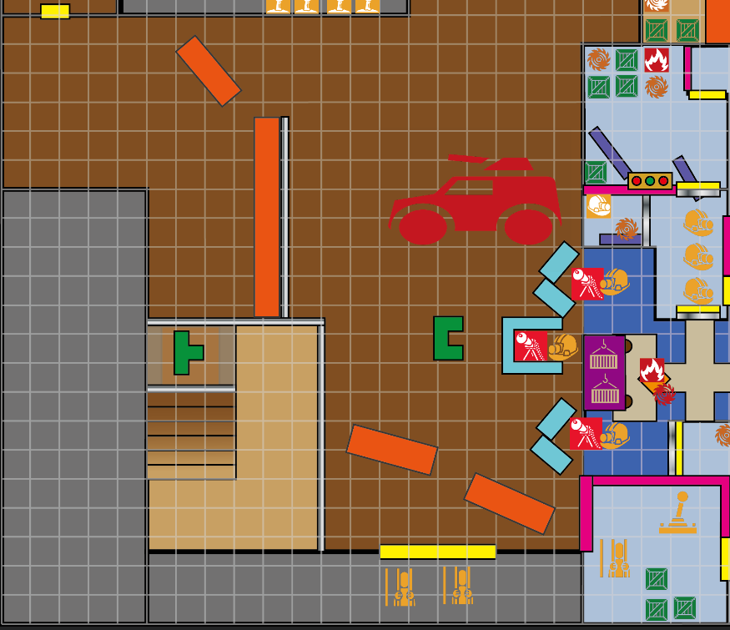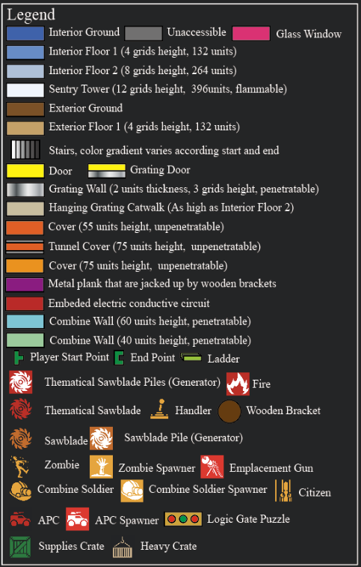
Figure 2: Seek a way in Overview Map [1,2,3]
Map Label | Event Summary | Event Details | Approx. Difficulty (1-10) | Approx. Time | Wow?
1 | Start points | The player is informed where the goal is and he/she needs to find another way in | 1 | 0:05
1a | Move to entrance | The player crouches to dodge the attack from combine troops and move toward the entrance | 1 | 0.30
1b | Move to next section | The player opens the door and leave this section | 1 | 0.40

Section 2: Thematical Break-in
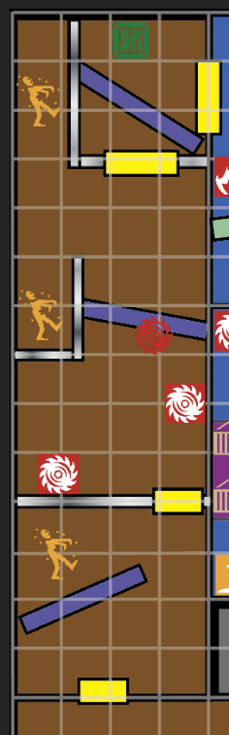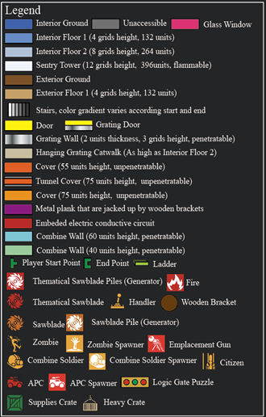
Figure 3 Thematical Break-in Overview Map [1,2,3]
Map Label | Event Summary | Event Details | Approx. Difficulty (1-10) | Approx. Time | Wow?
2 | Electric circuit panel | The player enters the section and see an aggressive zombie is killed by the electric panel | 1 | 0:45
2a | Thematical sawblade penetrating grating wall | The player enters the middle part of the section. Props drops from the left and right side onto the thematical sawblades piles and blow out two thematical sawblade. The sawblades fly toward the zombie and penetrate the grating wall and kill it | 1 | 0:50 | YES
2b | Thematical sawblade stop electric conduction | The player sees a thematical sawblade stuck in the electric circuit panel and the sparking of electricity stops and walk through it safely | 1 | 0:55
3 | Enter the warehouse | The player kills the zombie from the left corner and use the thematical sawblade to stop the electric circuit panel behind the grating wall . The player open the door and enter the warehouse (next section) | 2 | 1:15

Section 3: Sawblades and Zombies
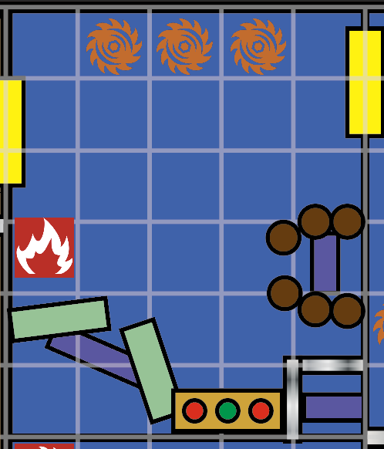
Figure 4 Sawblades and Zombies Overview Map [1,2,3]
Map Label | Event Summary | Event Details | Approx. Difficulty (1-10) | Approx. Time | Wow?
4 | Puzzle Room | The player enters the first room, which is a puzzle room, in the warehouse that possessed by the zombie | 1 | 1:30
4a | Penetrate combine wall | The player grasps, heats, and punches a thematical sawblade toward the combine wall. The sawblade penetrates the combine wall and hit the electric circuit panel behind it | 2 | 1:45 | YES
4b | Penetrate grating wall | The player grasps, heats, and punches a thematical sawblade toward the grating wall. The sawblade penetrates the grating wall and hit the electric circuit panel behind it | 2 | 2:00 | YES
4c | Penetrate the wooden brackets and ignite it | The player grasps, heats, and punches a thematical sawblade toward the wooden bracket. The sawblade penetrates the wooden bracket and hit the electric circuit panel behind it | 2 | 2:15 | YES
5 | Puzzle Solved | The player removes the sawblade from the panel behind the grating wall and the exit is unlocked. The player leaves the room and move to the next section | 2 | 2:45

Section 4: Zombie Cutter
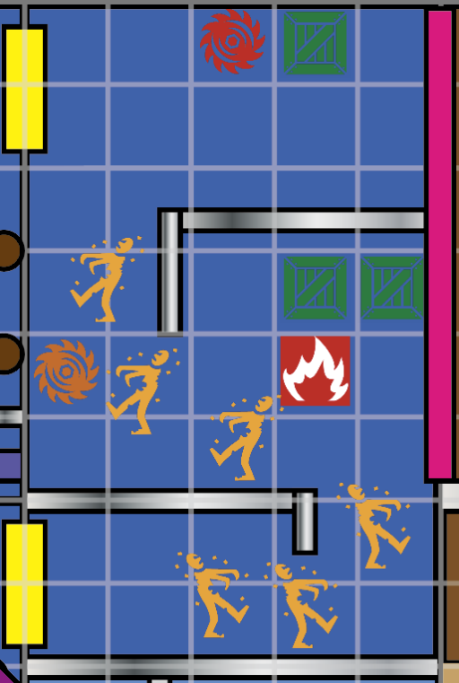
Figure 5 Zombie Cutter Overview Map [1,2,3]
Map Label | Event Summary | Event Details | Approx. Difficulty (1-10) | Approx. Time | Wow?
6 | Kill zombies | The player enters the room and see the thematical sawblade as well as the coming three zombies. The player kills the zombies by the thematical sawblade | 2 | 3:00
7 | Kill zombies | The player grasps the sawblade, heat it, and punch it toward the three zombies again to kill them | 2 | 3:15
8 | Leave the room | The player leave the room and head to the next section | 1 | 3:25

Section 4a: Ignition
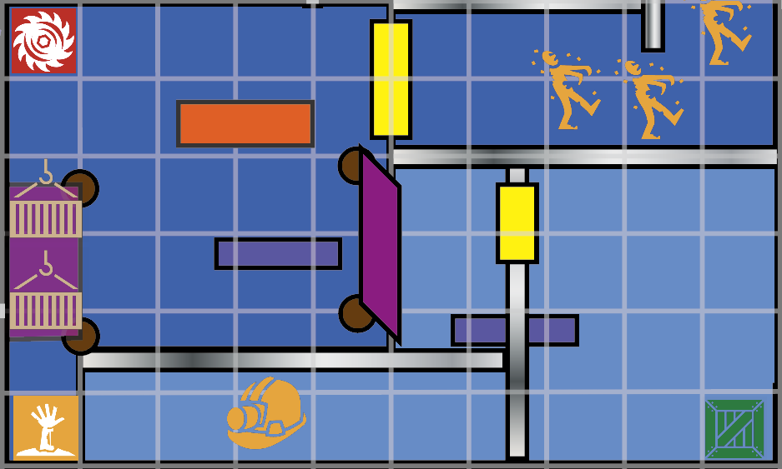
Figure 6 Ignition Overview Map [1,2,3]
Map Label | Event Summary | Event Details | Approx. Difficulty (1-10) | Approx. Time | Wow?
9 | Kill zombies and find its break-in position | The player enters the room and find that the zombie is kept spawning from stairs leading to the underground after fighting for a while | 3 | 3:55
10 | Block the break-in way | The player uses the thematical sawblade to ignite the wooden brackets in order to drop the heavy props on it to block the entrances of the zombies | 3 | 3:25
11 | Get the metal plank down | The player ignites the wooden brackets by thematical sawblade in order to get the metal plank down | 2 | 3:45
12 | Kill the break-in combine solider | A combine solider breaks in after the plank is got down by the player and shoot the player behind the grating wall. The player uses the thematical sawblade to kill | 3 | 4:00
13 | Leave the section | The player punches the sawblades to the electric circuit panel to stop the electricity and leave the section from the door | 2 | 4:15

Section 5: Bullet Rain
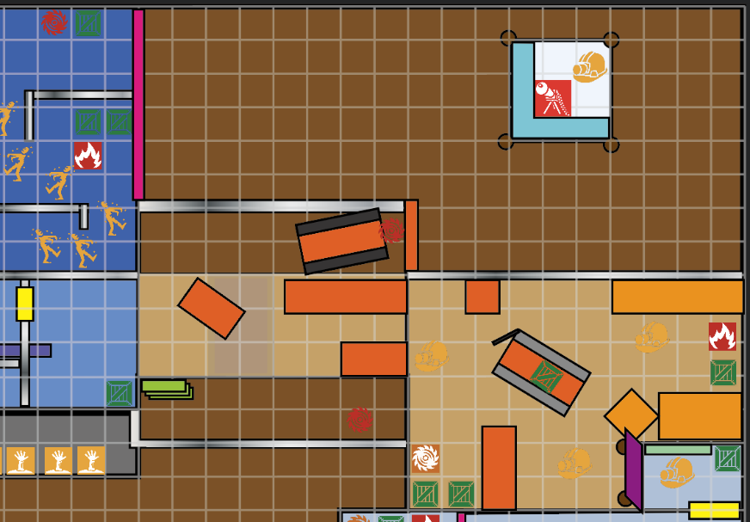
Figure 7 Bullet Rain Overview Map [1,2,3]
Map Label | Event Summary | Event Details | Approx. Difficulty (1-10) | Approx. Time | Wow?
13 | Crouch forward | The player crouches to escape from the attack from the sentry tower and move forward to across the bridge | 3 | 4:25
13x | Ignite the Sentry Tower (Optional) | The player jumps downs and punch the thematical sawblade found underneath the bridge toward the sentry. The sentry tower is ignited and explode. (The player can also do it by using others thematical sawblade found in this section) | 4 | 4:40 | YES
14 | Kill the first combine soldier at front | The player kills the first combine soldier met at front. | 4 | 4:45
14a | Kill the second combine soldier | The player grasps the sawblade, moves forward, and kill the second combine soldier by sawblade | 4 | 4:50
14b | Kill the third combine soldier | The player grasps the sawblade, moves forward, and kill the third combine soldier by the sawblade | 4 | 4:55
15 | Kill the combine soldier at height through the combine wall | The player moves forward with the sawblade and heat it to be thematical. The player punches it toward the combines soldier standing above behind the combine wall. The thematical sawblade kill the combine soldier | 5 | 5:05
16 | Get a new thematical sawblade | The player goes back and get a new sawblade and return to the fire to heat it to be thematical | 3 | 5:20
17 | Make a way to the entrance of the factory | Punch the new thematical sawblade to ignite the wooden brackets to get the metal planks down to make a way to the height place. | 3 | 5:30
18 | Enter the factory | The player walks to the door and leave this section | 2 | 5:35

Section 6: Bypass the Emplacement Gun
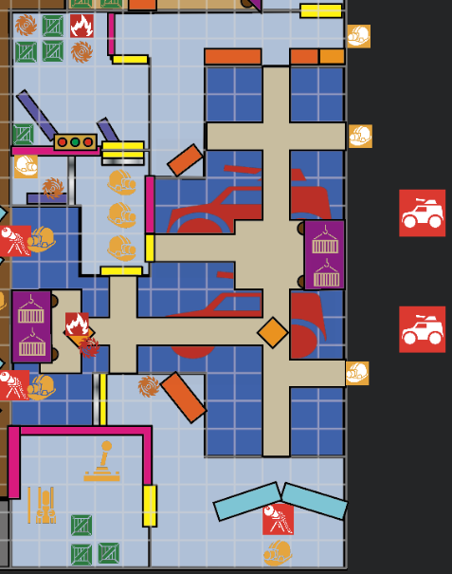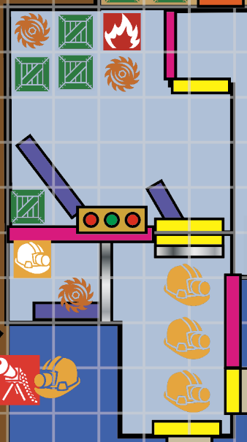
Figure 8 Bypass the Emplacement Gun Overview Map [1,2,3]
Map Label | Event Summary | Event Details | Approx. Difficulty (1-10) | Approx. Time | Wow?
18 | Find a way bypass the emplacement gun | The player enters the factory and find the catwalk is guard by the combine emplacement gun at the opposite platform. The player crouches and move to the | 3 | 5:40
19 | Solve the first part of the puzzle | The player search the room and find two sawblades. After heating them up and punching them on the electric circuit panels in a correct order (i firstly, ii secondly, then remove that on i), the door A open | 5 | 6:30
20 | Kill the combine soldiers | The player heats the sawblade to be thematical and punch toward the combine soldier to kill them at once | 4 | 6:40 | YES
21 | Solve the second part of the puzzle | The player grasps sawblades and heat them again. The player punches them to all the electric circuit panels and the exit will open. The player leave the room from the door | 4 | 6:55

Section 7: Rescue
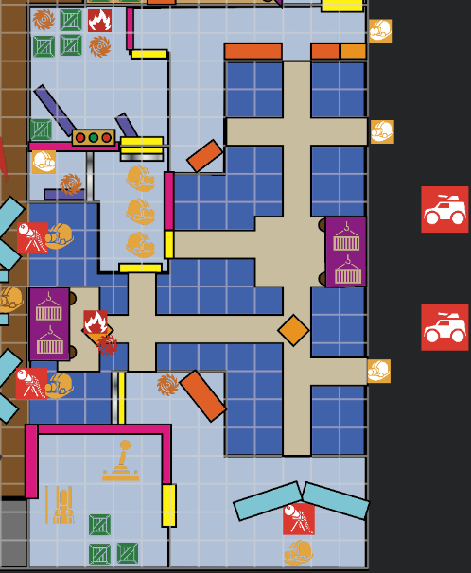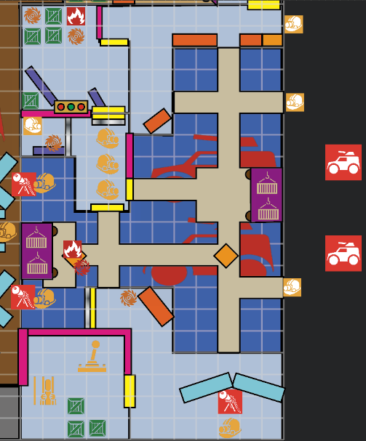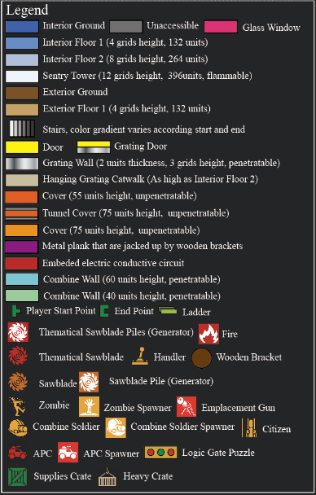
Figure 9 Rescue Overview Map [1,2,3]
Map Label | Event Summary | Event Details | Approx. Difficulty (1-10) | Approx. Time | Wow?
21 | Take down the emplacement gun | The player rushes forward to the corner of the room where the citizen leader is. The player turns back and grasps a thematical sawblade. Then, the player punches the sawblade toward the combine soldier behind the combine wall to kill it | 5 | 7:10
22 | Rescue the citizen leader (Narrative) | The player enters the room G1 and free the citizen leader, then pull the handle to open the gate for other citizens | 1 | 7:20
23 | Defeat all break-ins combine troop | After the player leaves the G1 room, the alarm is on, and the combine soldier starts to break in from the spawners. The player uses the emplacement gun to clear all of them. After that, 2 APC breaks in to the first floor and guard the area | 6 | 8:20
24 | Drop the catwalk | With the sawblade a and b in sequence, the player heats them and punch them in order to drop the heavy props iii, and iv on the catwalk in sequence. After that, the whole catwalk drops down and destroy the two APCs below | 4 | 8:40 | YES
25 | Leave the section | After the catwalk’s dropping, the grating door B will be destroyed, and the player jump down and leave this section | 1 | 8:45

Section 8: Way out
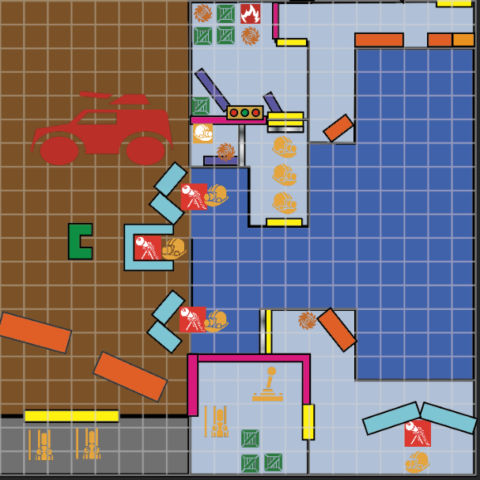
Figure 10 Way Out Overview Map [1,2,3]
Map Label | Event Summary | Event Details | Approx. Difficulty (1-10) | Approx. Time | Wow?
26 | Support the citizen | The player kills all the three combine soldiers using emplacement gun from their backs and use the emplacement gun to destroy the APC outside | 5 | 9:45
27 | End the game | The player leaves the factory and the game ends with fade out | 1 | 9:55

Skill Progression Chart
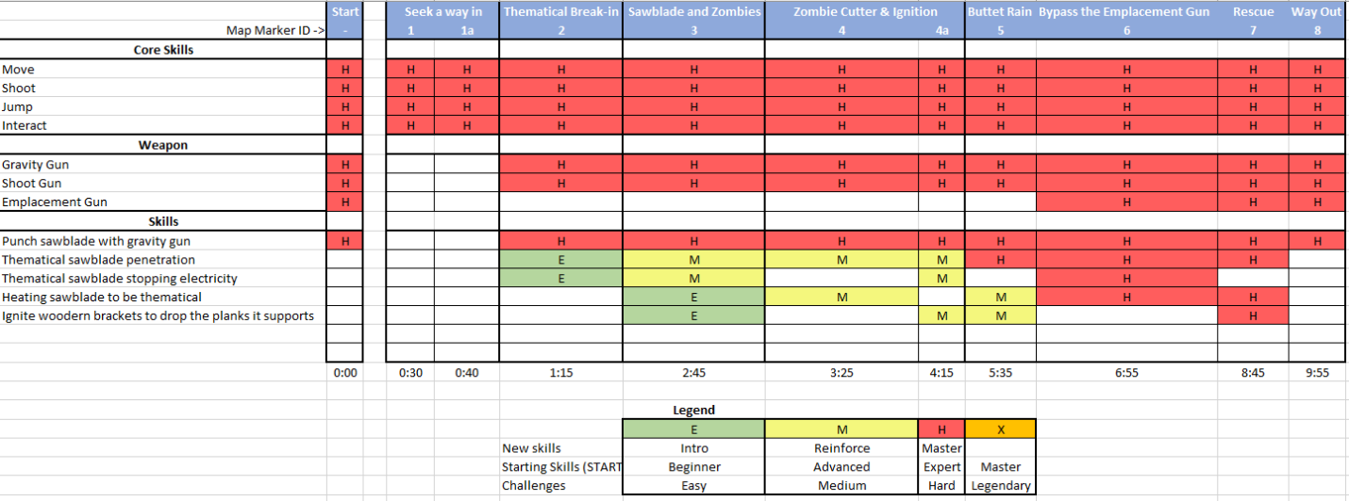
Figure 11 Skill Progression Chart [3,4]

New Skills/Gameplay Mechanics
- Penetrate Wall by punching thematical sawblade: It is a new mechanics that is intuitive while the player has never experienced in the Half-Left 2 episodes. The interesting interactions that are chained to this skill are that:
  - How the thematical sawblade is heated: a thematical sawblade can be retrieved by putting a sawblade on fire for a while
  - When the thematical sawblade is cool down: The gravity gun is the only way by which the player can interact with the thematical sawblade, and it acts as a warmer that keep a sawblade be thematical.
    - As soon as the player drops down the thematical sawblade, it will cool down and become a normal sawblade.
    - If the player punches the thematical sawblade, it will cooldown and become a normal sawblade as soon as it hit something
    - If the thematical sawblade is conducted by electricity, it will not cool down
    - When the player bring it out from a room, it will cool down
  - Damage: there is no damage if the player steps on a thematical sawblade. Yet, if the player grasps it without using the thematical gun, it will due small damage to the player in duration
  - On hitting entities:
    - When the thematical sawblade hit an enemy, it will ignite the enemies it hit, it will cool down after a while
    - When the thematical sawblade hit wooden props, the prop will be ignited, and a fire will remain at the place where it is hit. For a single wooden prop, it can be ignited for merely one time
    - When the thematical sawblade hits a metal bracket, it will cut it into two pieces
- Electricity Logic Gate Doors Controller
  - The door controller will be locked by up to 3 electric circuit panels that form a logical gate
  - They player punches the thematical sawblade on the panel to switch its input
  - There are red-green signal light on the wall that indicates the current states of the circuit panel, and the player needs to change it to be the same as the hint props (e.g. props that in green and red that in the puzzles room)

Hook(s)/Gameplay Highlights
- The super powerful thematical sawblade that can penetrate covers that the enemies hide, especially for the case that the enemy is using emplacement gun
- Ignite wooden construction to destroy it with explosion
- Emplacement gun smashing down enemies from multiple direction without takin risks
- Dropping props that smashes down the enemies

Context
One Way Out is a side-story that happened before Gordon Freeman returns to the City 17 in the chapter 10 “Anticitizen One”. Dr. Gordon is going to free the forced labors in the sawblade factory in the forest in order to expand the citizen’s troop. Therefore, Dr. Gordon needs to get access to the central controller observation unit to open the gate of the factory so that the citizen troops can rescue the workers. The level features in the atheistic of combating wrecked factory and warehouse as they are used in the Chapter Kannel.

Backstory
Although the citizen troops are ready to start a revolution in City 17, but it is always better to have more of the alliances to join the action. Hearing that hundreds of forced labors are locked in a sawblade production factory in the forest, Dr. Gordon decided to rescue these people from the control of the combine army. When Gordon reaches the forest where the factor is, he and his citizen troops was attacked by the zombie herbs and lose contact with each other. Gordon also lost some of his favor weapons except the gravity gun and shotgun. Gordon initially decided to seek for his lost troops first. Yet, he happened to reach the place where the factory is. Knowing that the factory is sieged by the zombie, Gordon thought that it is the best chance to break in and perform a rescue to the captive citizen. He decided to conquer the factory solely.

Aftermath
After saving the citizen, Dr. Gordon turns to find the lost citizen troops in the forest. There are several abandon villages in this forest which are either possessed by zombie or by combine army. Although it takes great time to search all of these places, the rescued factor workers can always provide sawblade for him, and he convinced that he could definitely find their alliances in the forest and return to the City 17. Future mission before the Chapter 10 “Anticitizen One” can be opened spaces missions that takes place in the forest as it is designed in the Chapter 7 “Highway 17”

Development Schedule
Milestone | Date
LDD | Oct. 31, 2022
Whitebox | Nov. 7, 2022
Initial Gameplay | Nov. 14, 2022
Gameplay Complete | Nov. 21, 2022
Aesthetics | Nov. 28, 2022
Launch | Dec. 5, 2022

Aesthetic References
The aesthetic theme of the level is identical as a style of factory and warehouse with exterior design as it is used in the Chapter 4 “Water Hazard”. For the interior design, the style, decay, and decorations should be in a style of steel factory in the last century. For the environment, the whole level should be surrounded by forest with green fog which delivers a feeling of decay forest giving a feeling that zombies is gathering to the place where the player is. The environment should be as it is before a storm.

“One Way Out” Contact Sheet
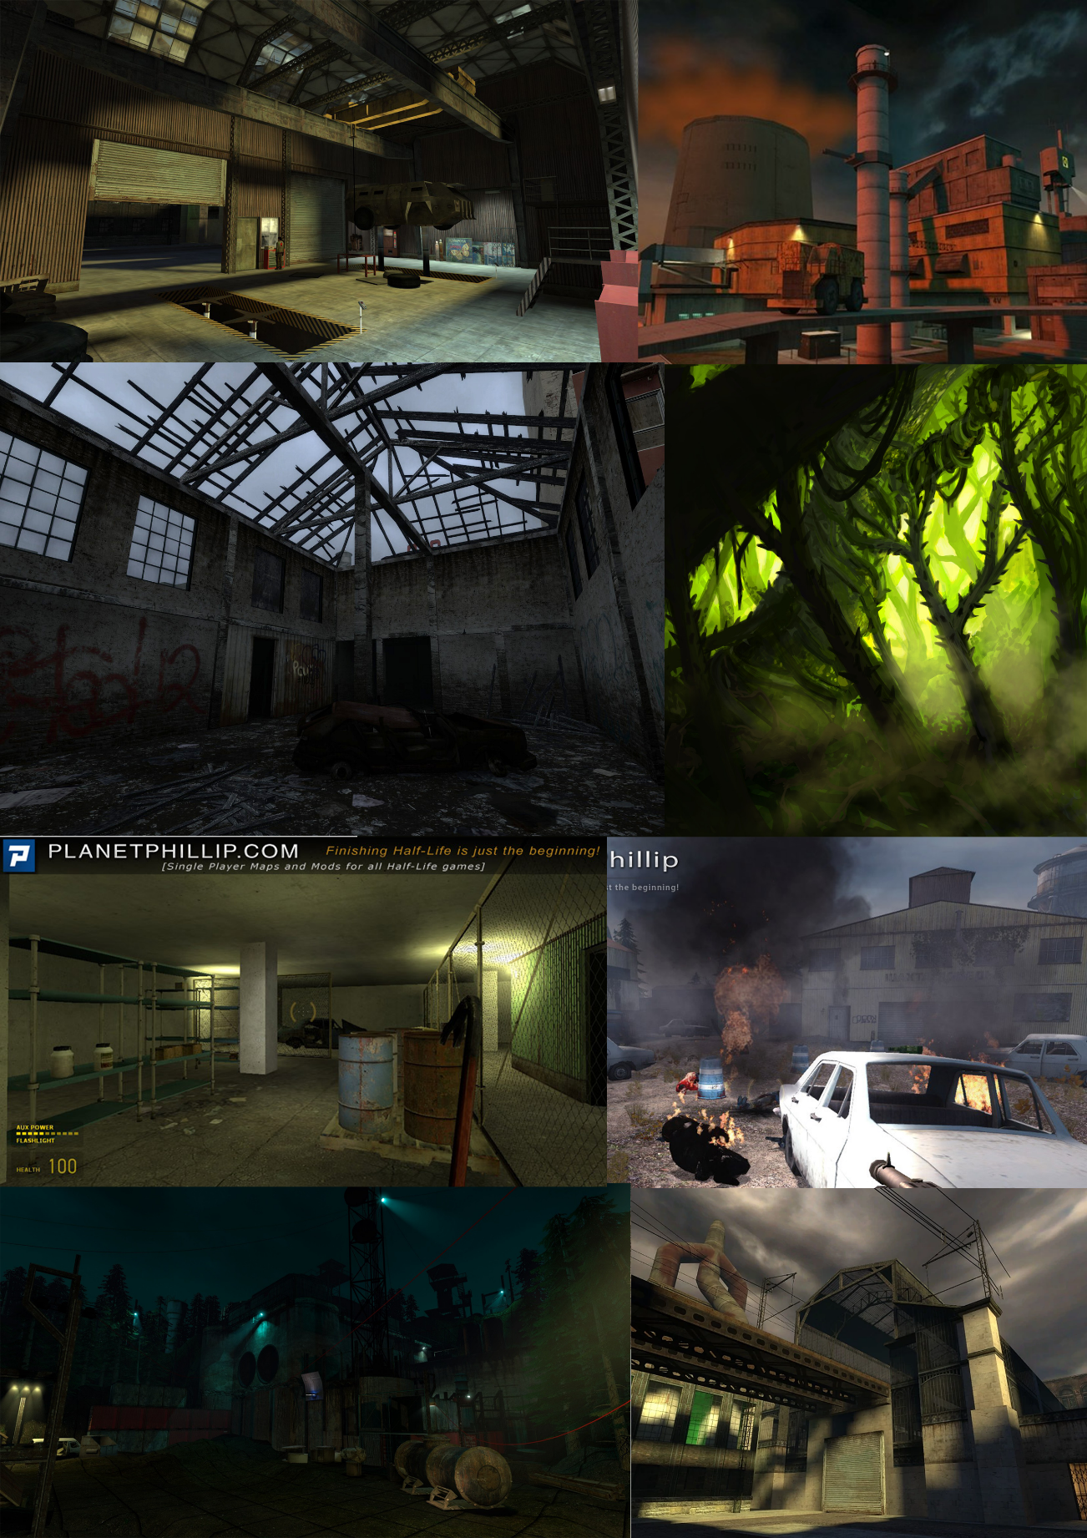
Figure 12 One Way Out Contact Sheet [5 - 12]

Unique Requirements and Risks
Map Label | Description | Type | Priority
2,3,4,4a,5,6,7 | Script the thematical sawblade for its mechanics involved in the level including its heating up, penetrating, interaction with other game objects that appears in the level | Major Scripting | Top
5 | Script for the destroy as well as explosion of the sentry tower | Environmental Event | Top
7 | Script for the following down of the whole catwalk | Environmental | Top
3, 6 | Script for the Logic Gate Puzzle based on Electric Circuit Panel | Major Scripting | Top
2,3,4,4a,5,6,7 | Script for the feedback for feedback and visual effect of the thematical sawblade when it is heated, when it cools down, and when it hits an enemy as well as other game objects | Major Scripting | Mid
2,3,4,4a,5,6,7 | Script for the penetrable props, the props’ penetrability should be changed when it is hit by thematical sawblade and when it is hit by normal stuffs | Major Scripting | Top
1,1a,7, 8 | The dialog as well as animation for the forced labors when the player starts the level as well as after rescuing the captured labor leader | Dialog | Mid
7 | The alarm audio which will turns on and off as well as break-in audio when combine soldiers spawn | Music & Audio | Mid
5,7,8 | Scripting for Combine Emplacement Gun that can be used by both NPC and player | Major Scripting | Top

Key Asset Needs
Description | Type | Priority
Zombie, Combine Soldier, and APC (Build in editor, combine soldier equipped with shotgun or SMG without any grenade) | Enemies | Top
Gravity Gun and Shotgun (Exist in editors) | Weapon | Top
Penetrated Props and props that they interacts with (Sawblade, Combine Wall, Combine Barricade, log, fence) | Physics Props | Top
Heating props made by particle (build in fire particle, furnace) | Environmental Props | Mid
NPC audio and Animation (Build-in-editor, but need to implement with sequencer) | Polish | Mid
Combine Emplacement Gun (Emplacement Gun, entity tank, trigger) | Weapon | Top
Electric Circuit Panel (combinecore, metal door) | Game Objects | Top
Sentry Tower (Build in Prefab but needs modification) | Construction | Top
Catwalk (metalgrate, metal cable) | Environmental Props | Top
Factory Environmental sets (bricks, metal, grating, grass, sand, tools, labs models, plaster, glass) | Environmental Props | Mid
Sky (skybox, sky_day01) | Skybox | Mid

References
[Cover Image] Moreschi, “MORESCHI'S SAW BLADES,” Moreschi Lame, 30-Jun-2020. [Online]. Available: http://www.moreschi.eu/en/circular-saw-blades/. [Accessed: 28-Oct-2022].
[1] Li, Donghua, “Level Overview Map”, created by Adobe Illustrator, Oct. 30, 2022.
[2] Icons for thematical sawblades piles, thematical sawblade, handler, wooden bracket, fire, sawblade, sawblade pile, zombie, zombie spawner, emplacement gun, combine soldier, combine solider soldier spawner, citizen, APC, APC spawner, supplies grate, and heavy crate from “Already 4122 free icons for your games,” Game. [Online]. Available: https://game-icons.net/. [Accessed: 30-Oct-2022]
[3] Valve Develper Community, “Half-life 2,” Half-Life 2 - Valve Developer Community. [Online]. Available: https://developer.valvesoftware.com/wiki/Half-Life_2. [Accessed: 30-Oct-2022].
[4] Li, Donghua, “Skill Progression Chart”, created by Microsoft Excel, Oct. 30, 2022.
[5] Витой, “City 17 chapter mod,” H λ L F - L I F E Project Beta. [Online]. Available: https://hl2-beta.ru/index.php?topic=28088.0. [Accessed: 31-Oct-2022].
[6] Doomer Doge, “Half-life 2 beta - air exchange ambience,” SoundCloud. [Online]. Available: https://soundcloud.com/user-5617209/half-life-2-beta-air-exchange-ambience. [Accessed: 31-Oct-2022].
[7] demodad235, “SP_FACTORYDEFENSE [half-life 2] [mods],” GameBanana, 14-Apr-2020. [Online]. Available: https://gamebanana.com/mods/57270. [Accessed: 31-Oct-2022].
[8] Shadgrimgrvy, “Paranoia abstract,” rtsl-52×56. [Online]. Available: https://www.runthinkshootlive.com/posts/paranoia-abstract/. [Accessed: 31-Oct-2022].
[9] Yaroslav, Karpenko, “Yaroslav Karpenko - Muterunaway - half-life 2 mod,” MuteRunaway - Half-Life 2 mod, 08-Jun-2019. [Online]. Available: https://snaksan.artstation.com/projects/KaLWbx. [Accessed: 31-Oct-2022].
[10] “Combine factories,” The Half-Life &amp; Portal Encyclopedia. [Online]. Available: https://half-life.fandom.com/wiki/Combine_Factories. [Accessed: 31-Oct-2022].
[11] M. Kalman, “Artstation - explore,” Menace Forest, 2018. [Online]. Available: https://www.artstation.com/artwork/. [Accessed: 31-Oct-2022].
[12] Li, Donghua, “One Way Out Contact Sheet”, created by Adobe Photoshop, Oct. 31, 2022.

