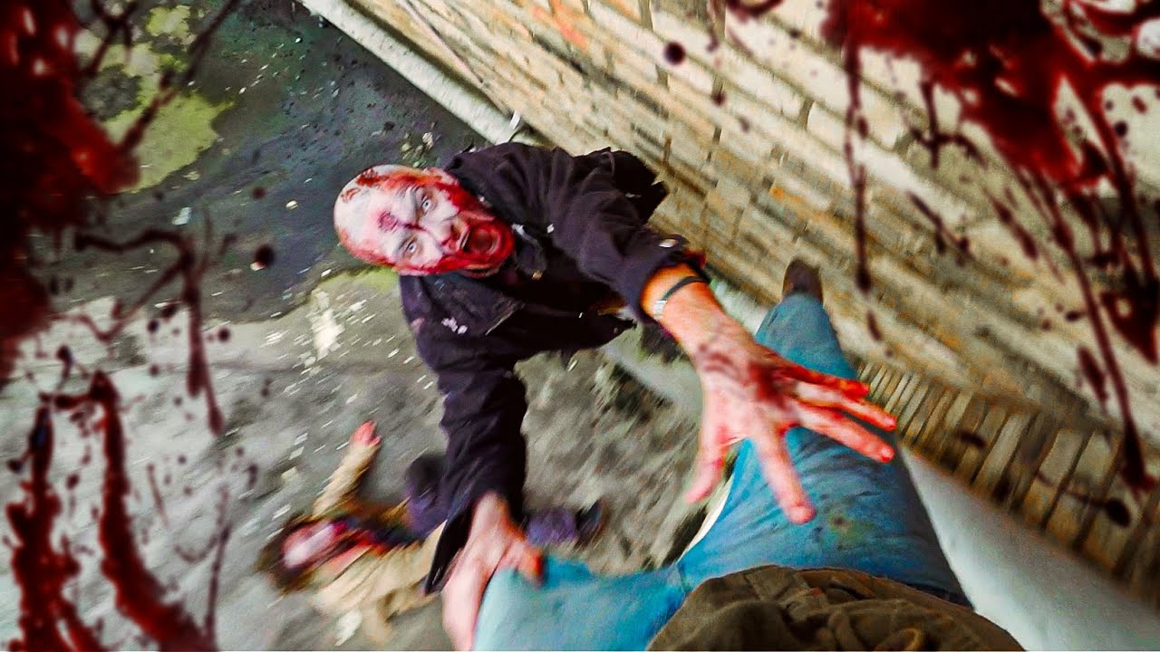

Dying Light: Falling Object
  - Version 1.0
Designer: | Donghua Li
Document Date: | November 29, 2023
Intended Level Delivery Date: | December 4, 2023

Document Revisions Table
Version | Description | Requestor | Date
1.0 | LDD Document | Professor. Stephen | October 2, 2023

Table of Contents
Table of Contents 2
Table of Figures 3
Level Summary 4
Quick Summary 4
Level Feature Overview 4
Development Schedule 5
Level Overview 6
Overview Map 6
Narrative Flow Chart 7
Level Details 8
Detail Maps 8
Slum Street 8
Archery Range 9
Chemical Factory 1st Floor 10
Chemical Factory Roof Top 12
Skill Progression Chart 14
Aesthetic References 15
Slum Streets 15
Abandoned Factory and Archery Club 16
References 17
Appendices 19
Appendix A: New Skills / Gameplay Mechanics 19
Appendix B: Context 20
Backstory 20
Aftermath 20
Appendix C: Character Descriptions 20
NPC 1: Rahim Aldemir 20
Appendix D: Dialog Flow 21
Appendix E: Development Risks 22
Appendix F: Key Asset Needs 23

Table of Figures

Figure 1: Overview Map [13] 6
Figure 2: Detailed Map of Slum Street [13] 8
Figure 3: Detailed Map of Archery Range [13] 9
Figure 4: Detailed Map of Chemical Factory [13] 10
Figure 5: Detailed Map of the Chemical Factory Roof Top [13] 12
Figure 4: Skill Progression Chart [14] 14
Figure 5 Contact Sheets of Slum Street theme 15
Figure 6 Contact Sheet of Factory theme and archery club 16

Level Summary

Quick Summary
Falling Object is a Dying Light standalone level featuring in parkour and arrow combat. In this level, the protagonist Crane will start from a roof of a high-rise building and is trying to reach the opposite building to talk to Rahim to continue a mission. However, the cable walk breaks when Crane is going across it. Fortunately, he falls down into a garbage pile at the bottom. Crane needs to find a new way going back to the top of the building and meet Rahim.

Level Feature Overview
Category | Sub-Category | Feature List
Player | Player Weapons | - Bow with burning arrow
 | Player Skills/Abilities | - Stepping on zombie to move forward  - Parkour  - Shooting arrows  - Ignite oil trap by burning arrow
AI | Enemies | - Bitter  - Viral  - Goon
 | Friendlies | - N/A
Challenges | Gameplay Themes | - Escape/ Run away  - Parkour  - Bow & arrow shooting
 | Obstacles/Hazards | - Burning Oil Trap
 | New/Unique Gameplay | N/A
Context | Where Fits in Game | It is a standalone quest from the main story taking place when Rahim and Crane are working on a mission practicing the parkour together
 | Challenge Fit | - The level provides challenges of parkouring to escape from chasing enemies.  - It verifies player’s skills of finding the correct direction to move forward while being chased by enemies  - The level also challenges player’s skills of shooting arrow with bow
 | Additional Info | N/A
Aesthetics | Major Visual Themes | - Slum Street  - Chemical Factory
 | Setting/Mood | - Nervous

Development Schedule
Milestone | Date
LDD | Oct 2, 2023
Whitebox | Oct 16, 2023
Initial Gameplay | Nov 6, 2023
Gameplay Complete | Nov 20, 2023
Aesthetics | Nov 27, 2023
Launch | Dec 4, 2023

Level Overview

Overview Map
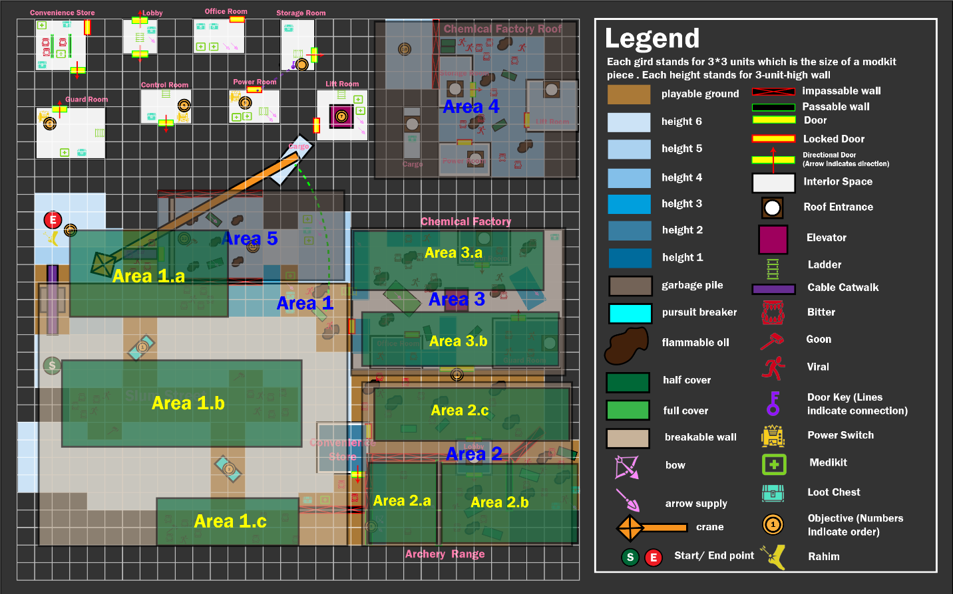
Figure 1: Overview Map [13]
Map Label | Gameplay Summary
1 | Area 1 is a slum street where the player needs to escape from by parkouring. The goal is to reach the climbable wall at the end of the street
2 | Area 2 is an Archery Range where the player gets the weapon, a bow with burning arrows and learns how to aim and shoot with it. The player will also learn how to use the burning arrows to ignite the oil on ground to fight with grouped enemies. The goal is to reach the gate of the next area
3 | Area 3 is the first floor of the Chemical Factory. They player needs to turn on two power switches to activate the elevator to go upward to the factory roof
4 | Area 4 is the roof of the Chemical Factory. The player needs to help Rahim to gain the access of the crane so that he can make a way for the player to get the roof of the higher building
5 | Area 5 is the roof top close to the building where the player wants to get to at the beginning. The player needs to defeat a goon boss here to converge with Rahim

Narrative Flow Chart
N/A

Level Details

Detail Maps

Slum Street
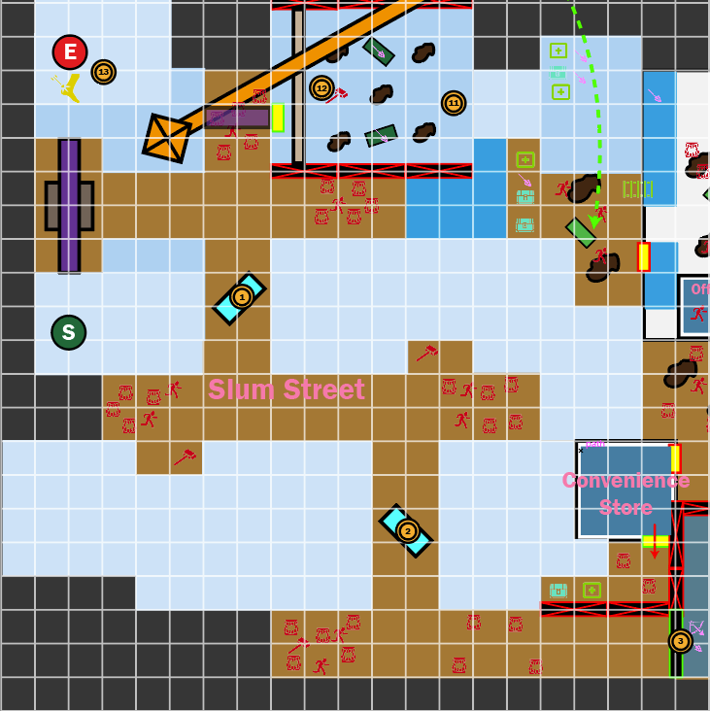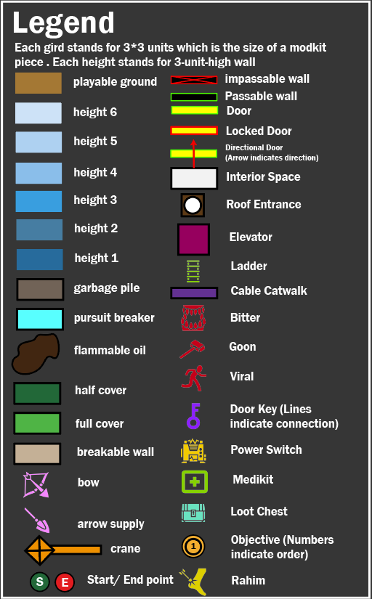
Figure 2: Detailed Map of Slum Street [13]
Map Label / Stage | Event Summary | Event Details
1 | Try to converge with Rahim | The player goes across the cable catwalk to converge with Rahim. However, when the player is about the middle of the cable, it breaks, and the player falls down to the garbage pile at the bottom
2 | Reach the first pursuit breaker car | Having no weapon, the player cannot fight with zombies. So he needs to escape from this slum street to gain weapons in a nearby archery range told by Rahim.  - Move forward and make a right turn.  - Climb and go across the car which is the objective 1
3 | Reach the second pursuit breaker car | - Make a left turn and run forward  - Make a right turn and climb on the car which is the objective 2 to go across it
4 | Reach the Archery Range | - Make a left turn  - Kit away or step on the bitters blocking the lane  - Climb on the wall at the end of the street to go across it

Archery Range
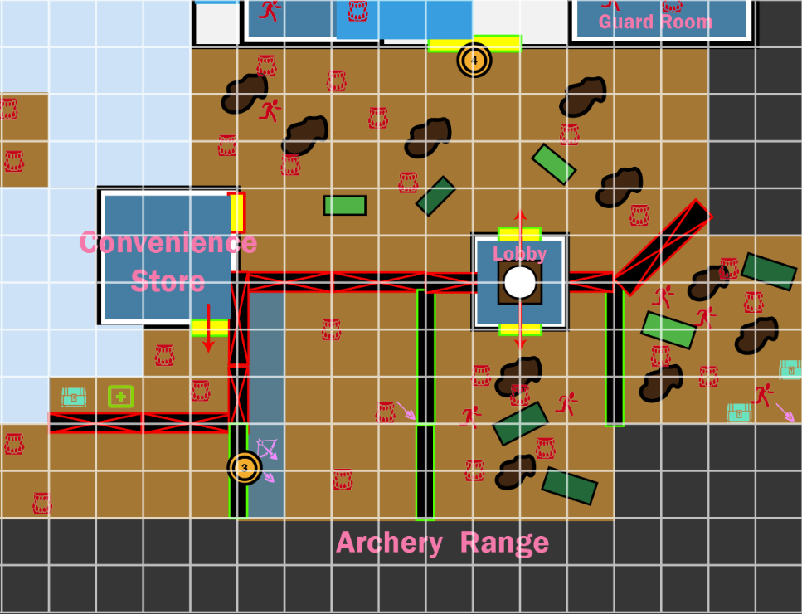
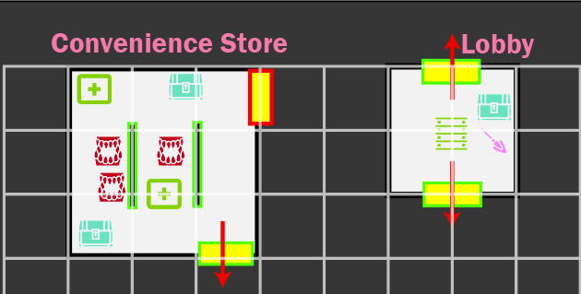
Figure 3: Detailed Map of Archery Range [13]
Map Label / Stage | Event Summary | Event Details
5 | Gain and practice using bow | - Loot the bow and arrows from the floor  - Use bow to kill the bitter on the ground
6 | Reach the range’s lobby | - Climb across the wall in the middle of the range  - Use burning arrows to ignite the oil on the ground to burn the zombie on the other side of the wall
7 | Enter the Chemical Factory | - Climb up to the roof of the Lobby  - Jump down to the street in front of the Chemical Factory  - Enter the Chemical Factory by defeating the enemies blocking the way

Chemical Factory 1st Floor
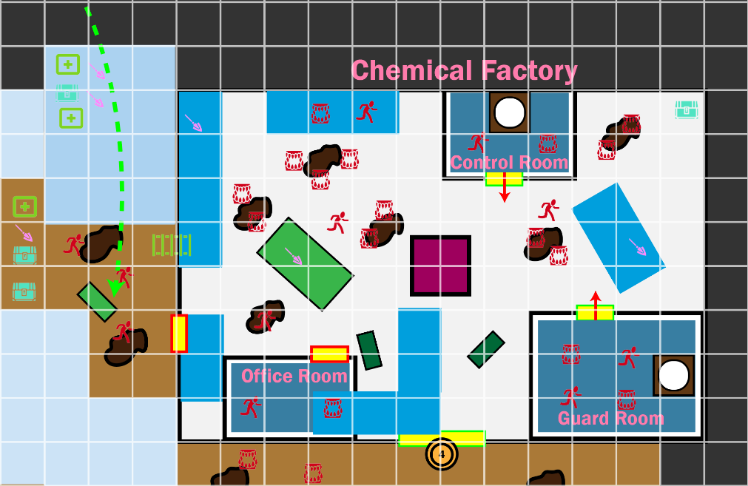
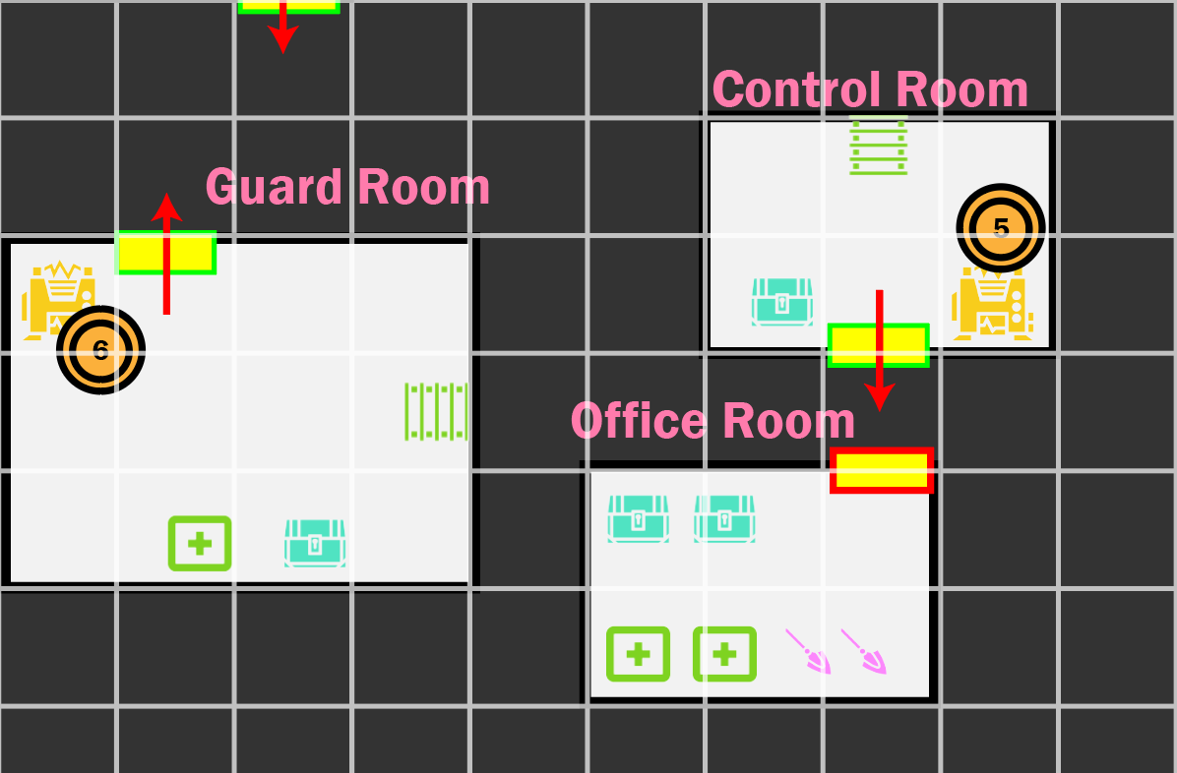
Figure 4: Detailed Map of Chemical Factory [13]
Map Label / Stage | Event Summary | Event Details
8 | Reach the platform A | According to Rahim, the player needs to get to the roof of the factory so that Rahim can help him get back to where he is. To do it, they player needs to activate the elevator going upward by activating the power boxes in the Control Room and the Guard Room  - Make a left turn after entering the factory  - Climb up to the cargo i  - Jump and climb up to the platform A and go to its end
9 | Enter the Control Room | - Defeat the enemies on platform B  - Jump to the platform B  - Jump to the roof of the control room after defeating the enemies on it  - Jump in the top window ii to get in the Control Room
10a | Activate the first power box for the elevator | - Pull the handle on the power box by the wall
10b | Go back to the roof of the Control Room | - Turn back, use the ladder to climb up to the roof
11 | Enter the Guard Room | - Jump to the platform C  - Defeat the enemies on the top of the Guard Room  - Jump to the top of the Guard Room  - Jump in the top window iii to get into the Guard Room
12 | Activate the second power box for the elevator | - Go to the power box and pull the switch to activate it  - Leave the Guard Room from its door
13 | Get into the elevator | The door of the elevator is stuck by the crate boxes in it. The player needs to enter it from it top  - Climb to the cargo i again and jump to the platform A again  - Make a left turn and jump on to the platform D  - Defeat the enemies on the top of the Office Room  - Jump to the roof of the Office Room  - Climb up to the platform E and make a left turn  - Jump down to the top of the elevator to get into it  - Press the button in the elevator to go upward to the roof

Chemical Factory Roof Top
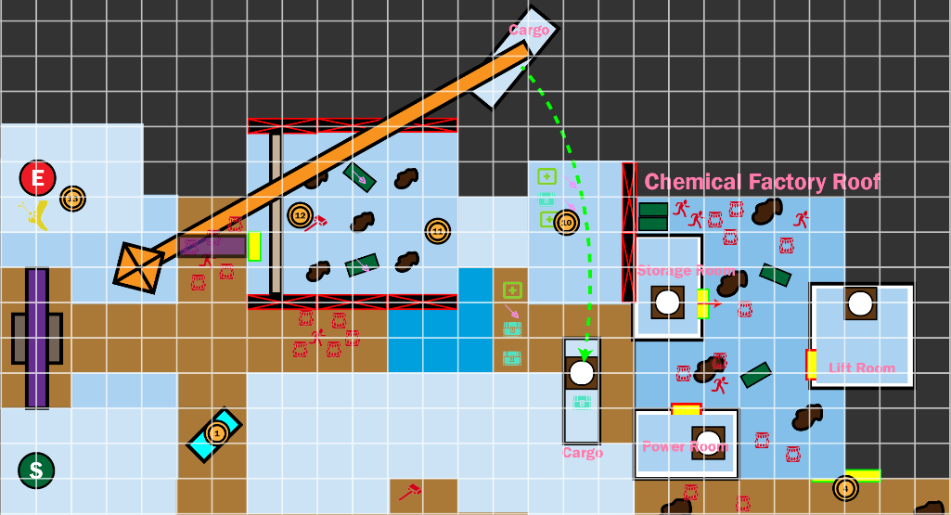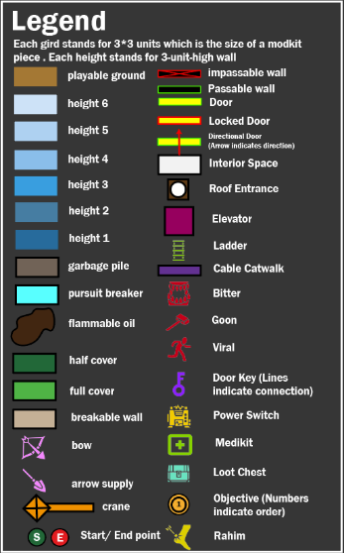
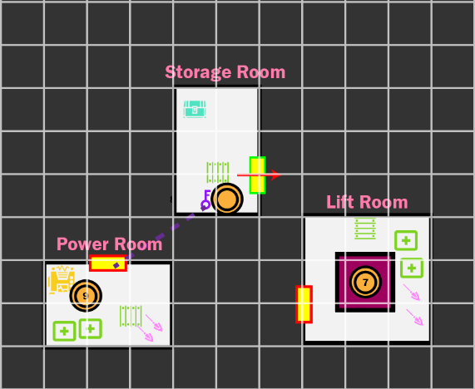
Figure 5: Detailed Map of the Chemical Factory Roof Top [13]
Map Label / Stage | Event Summary | Event Details
14 | Get out from the Lift Room on the roof | After reaching the roof, Rahim tells the player that he needs the player to help him get access to the nearby crane machine. To do it, he needs the player to get into the Power Room to manipulate the control authorization  - Leave the Lift Room by the ladder or its front door
15 | Get into the Storage Room | After checking that the Power Room’s door is locked, Rahim tells the player there might be a key nearby  - Make a jump to the ground and go to the Power Room. Try to open its door  Turn back and go to the end of the roof and jump to the top of the Storage Room  Jump in the Storage Room from its top window
16 | Get the key of the Storage Room | - Take the key on the table  - Turn left and leave the Storage Room
17a | Help Rahim get control of the crane | - After leaving the Storage Room, make a left turn and go to the Power Room  - Use the key to open the door of the Power Room and enter it
17b | Pull the switch on the table and leave the Power Room | - Make a right turn and go to the table where the power box is  - Pull the switch to activate it
17c | Get to the top of the Power Room | - Turn around and use the ladder to climb to the top of the Power Room
18 | Reach platform 18 | After reaching the roof of the Power Room, Rahim operates the crane and swiping all the zombies on the roof F with the cargo hanging on the crane. The cargo stops by the Power Room  - Jump to the Cargo  - Go to its ends and jump to the roof F
19 | Enter the Boss Room | - Climb up to the platform G to move forward  - Jump down to roof H  - Defeat the Goon Boos coming out from the breakable wall
20 | Converge with Rahim | - Loot the key from the Goon and open the door iv after the broken wall  - Go across the cable catwalk and climb up to the roof I to meet Rahim there  - Level Finished

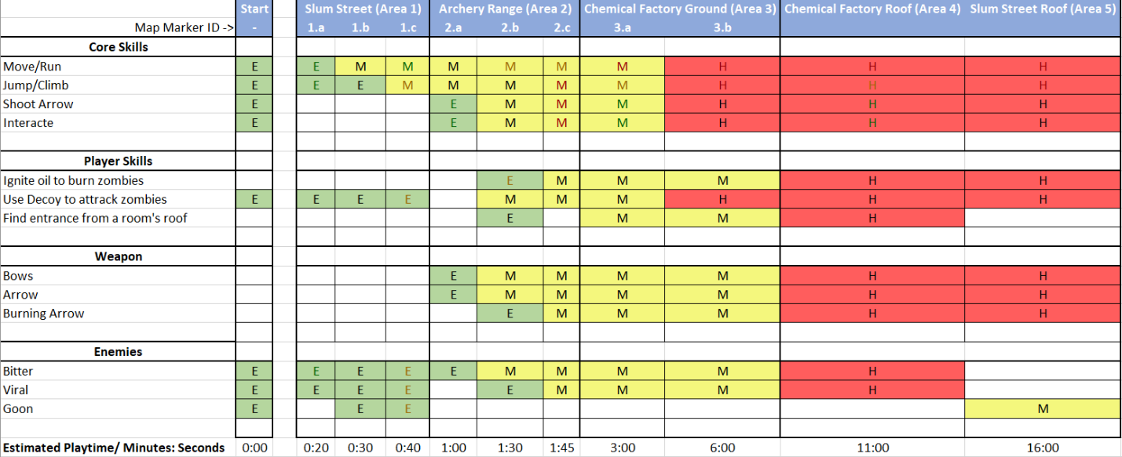
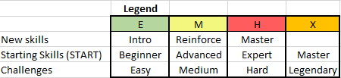
Skill Progression Chart
Figure 4: Skill Progression Chart [14]

Aesthetic References
In general, the level happens in a high-rise slum area near a river. The player will start from the top of a building. Then, the player will fall down to the slum street which is jammed with zombies. After the player leaves the slum street, the player will enter a slum commercial area with an archery range. Later the player will enter an abandoned factory of chemicals.

Slum Streets
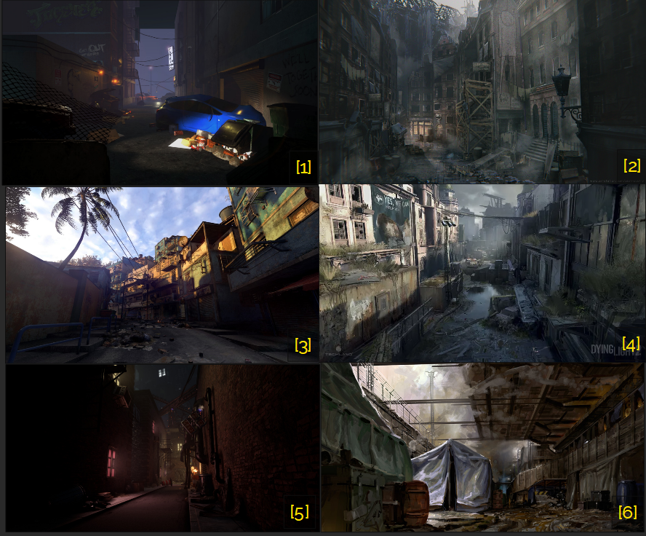
Figure 5 Contact Sheets of Slum Street theme [15]

Abandoned Factory and Archery Club
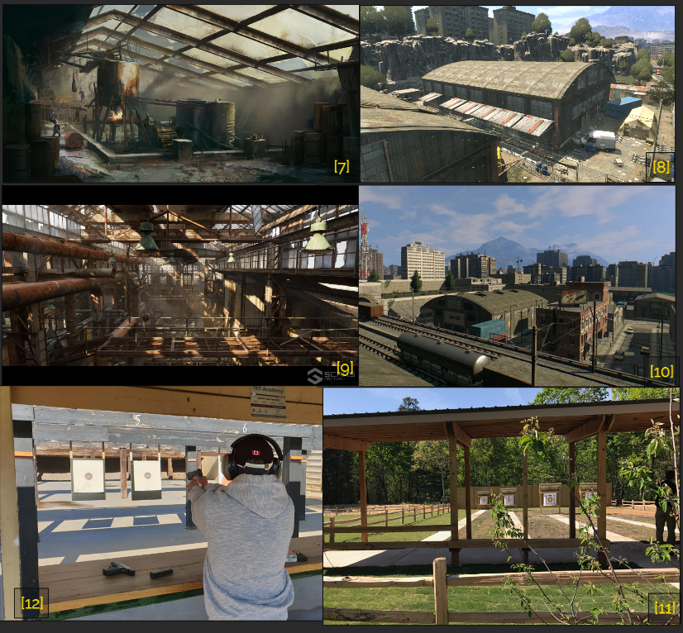
Figure 6 Contact Sheet of Factory theme and archery club [15]

References
[Cover Image] AMPISOUND, “Dying Light - Zombie Escape Parkour POV ,” YouTube, https://www.youtube.com/watch?v=jPhuefvauuk (accessed Sep. 19, 2023).
[1] S. Denmark, “Zombie Shooting Game,” Artstation, https://www.artstation.com/artwork/oO6ZaW (accessed Sep. 19, 2023).
[2] P. Bystry, “Burned old town,” ArtStation, https://www.artstation.com/artwork/YaDXqY (accessed Sep. 20, 2023).
[3] INVICT, “Dying Light 2 - Favela,” ArtStation, https://www.artstation.com/artwork/Ke4A0G (accessed Sep. 19, 2023).
[4] “Dying Light Delayed With No New Release Date Set,” 36861347 - Online Store, https://salelesov.life/product_details/36861347.html (accessed Sep. 19, 2023).
[5] H. Lissner, “Alleyway Slum,” ArtStation, https://www.artstation.com/artwork/baxrza (accessed Sep. 20, 2023).
[6] H. Karppimem, “Cyberpunk Art - Derelict Sector - Lore Wise Games: Sci-fi Stock Art,” DriveThruRPG, https://www.drivethrurpg.com/product/380886/Cyberpunk-Art--Derelict-Sector (accessed Sep. 19, 2023).
[7] thedoctorisin7863, “Dying Light 2 concept art pool,” Reddit, https://www.reddit.com/r/dyinglight/comments/brnp2r/dying_light_2_concept_art_pool/ (accessed Sep. 20, 2023).
[8] “Chemical Storage,” Dying Light Wiki, https://dyinglight.fandom.com/wiki/Chemical_Storage (accessed Sep. 20, 2023).
[9] Scans Factory, “[SCANS] Warehouse - Abandoned Factory District in Environments - UE Marketplace,” Unreal Engine, https://www.unrealengine.com/marketplace/en-US/product/scans-warehouse-abandoned-factory-district?sessionInvalidated=true (accessed Sep. 20, 2023).
[10] will2kk, “Assault on Warehouse 72 - Short single player/coop mission - Tribute to Counter-Strike’s cs_assault in Dying Light,” Reddit, https://www.reddit.com/r/dyinglight/comments/gxu0wd/assault_on_warehouse_72_short_single_playercoop/ (accessed Sep. 20, 2023).
[11] “Archery and Air Gun Range,” Unicoi State Park &amp; Lodge - Helen, GA, https://www.unicoilodge.com/adventures/3-d-archery/ (accessed Sep. 20, 2023).
[12] C. Barlow, “Dallas’ Best Shooting Range [Updated 2023],” Dallas Nav, https://dallasnav.com/best-shooting-range-in-dallas (accessed Sep. 20, 2023).
[13] Li, Donghua, “Overview Map”, “Detailed Map of Slum Street”, “Detailed Map of Archery Range”, “Detailed Map of Chemical Factory”, “Detailed Map of the Chemical Factory Roof Top”, created by Adobe Illustrator, Sep 25, 2023.
[14] Li, Donghua, “Skill Progression Chart”, created by Microsoft Excel, Sep. 26, 2023.
[15] Li, Donghua, “Contact Sheets of Slum Street theme”, “Contact Sheet of Factory theme and archery club”, created by PureRef, Sep. 26, 2023.

Appendices

Appendix A: New Skills / Gameplay Mechanics
N/A

Appendix B: Context
While walking across a building, the cable walk suddenly breaks and Crane falls down to slum alley jammed with zombies. Fortunately, the garbage pills underneath save Crane from death. However, the great noise of falling down definitely catches the attention of the nearby zombie. Without any weapon on hand, Crane needs to escape from the alley and seek a way back to the top of the roof where Rahim is.

Backstory
The level Falling Object is a standalone mission happening after the Rahim taught Crane about parkour. He invites Crane to do some practice on it together while delivering an item to another team working on their mission. The story takes place on the halfway point to the place where that team is.

Aftermath
After returning to the roof and meeting Rahim there, Crane and Rahim are going to move on to the highway bridge to seek the team that they are going to deliver the item to.

Appendix C: Character Descriptions

NPC 1: Rahim Aldemir
Description | Rahim Aldemir is the quest giver of the mission in this level
Background | Assistant Leader of the Tower
Goals/Motivation | Giving Crane instruction of how to go back to the roof top
Personality/Archetype | Brave
Relationships | Practicing parkour with Crane in another mission. The story of this level happens before it starts

Appendix D: Dialog Flow
N/A

Appendix E: Development Risks
Map Label | Description/ | Mitigation | Type | Priority
1.a | Player might don’t know where to go | Use spotlight or fire hazard to push the player toward the correct direction | Design | High
Area 3 | The elevator might have assets trouble and scripting trouble | Instead of moving the elevator via movie. Do teleporting the player to the roof | Scripting | Medium
Area 4 | Movie with physical constrain might have scripting issues | Just cut the Wow moment of swiping all enemies on the roof by the cargo hanged on crane | Scripting | Medium

Appendix F: Key Asset Needs
Asset Keyword | Description | Type | Priority
Concrete | The wall piece for the factory | Mod Kit | High
Vehicle | Obstacles, save place, and chase breaker | Mesh model | High
Cable | The catwalk connecting high-rise building | Mod Kit | High
Wall_str | Straight wall piece keyword for tall buildings | Mod Kit | High
Int_low_wall_a_anim | The breakable walls | Mod Kit | Medium
Baldachain | The pergola frame of the archery range | Mod Kit | High
ZZZZ_Ammo_Arrow | Normal bow arrow | Item | High
ZZZZ_Ammo_Arrow_Burning | Burning bow arrow | Item | High
Puddle | The oil puddle on the floor | Mesh | High
Crate, boxes | The boxes and crate that allow the player to climb | Mesh | Medium
Door
Fence, T-wall | Unclimbable Wall limiting the range of the playable area visually | Mod Kit | Medium
Bailey | The river bank asset collection | Mod Kit | Medium
Bridge | The highway by the start and end position | Mod Kit | low
Rock | Environmental piece for the surrounding | Mod kit | low
Crane | The crane cart assets group | Mod Kit | Low

